6001CEM – Individual Project

Individual Project Report

Fingerprint Attendance Technology: Revolutionizing Academic Tracking and Security in the Education Sector

Name: Asim Adalat

Student Identification No.: 11068789

Supervisor Name: Dr Katerina Stamou

Ethics Reference No.: P167321

**6001CEM Declaration of originality**  
**(This form should be completed by the student and included in the project report)**  
  
***I Declare that this project is all my own work and has not been copied in part or in whole from any other source except where duly acknowledged. As such, all use of previously published work (from books, journals, magazines, internet etc.) has been acknowledged by citation within the main report to an item in the References or Bibliography lists. I also agree that an electronic copy of this project may be stored and used for the purposes of plagiarism prevention and detection.***

**Statement of copyright**

I acknowledge that the copyright of this project report, and any product developed as part of the project, belong to Coventry University. Support, including funding, is available to commercialize products and services developed by staff and students. Any revenue that is generated is split with the inventor/s of the product or service. For further information, please see www.coventry.ac.uk/ipr or contact [ipr@coventry.ac.uk](mailto:ipr@coventry.ac.uk).

**Statement of ethical engagement**  
I declare that a proposal for this project has been submitted to the Coventry University ethics monitoring website (https://ethics.coventry.ac.uk/) and that the application number is listed below (Note: Projects without an ethical application number will be rejected for marking).

Signed: Date: 11/04/2024   
Electronic signature is acceptable  
  
Please complete all fields.



|  |  |
| --- | --- |
| First Name: | Asim |
| Last Name: | Adalat |
| Student ID number | 11068789 |
| Ethics Application Number | P167321 |
| Supervisor | Dr Katerina Stamou |

This form must be completed, copied, or scanned and included with your project submission to Turnitin. Failure to append these declarations may result in your project being rejected for marking.

Acknowledgements

It has taken a great deal of time and effort to compile the information found in this study.

This would not have been possible without the help of a few individuals/organizations so I would like to show my appreciation by extending a sincere thank you to all of them.

I am highly appreciative of Dr Katerina Stamou for her constant guidance and supervision during the course of this project. The necessary information provided by my supervisor helped form a comprehensive and detailed study.

I wish to express my gratitude towards my parents owing to their support for my undertaking of this project and continual encouragement which allowed me to meet my timed goals set over the course of the study.

A final thanks is owed to Coventry University for creating a positive learning environment and for the provision of the Digital Literacy Centre, a vital asset in the pursuit of knowledge.

Abstract

The aim of this project is to utilise biometrics to record attendance, optimising the process by ensuring reliable identification of students and eliminating the false positives and negatives caused by human error. Traditional methods are prone to numerous issues, and some may be considered outdated in a modern digital society. Biometric techniques can be employed to reduce security risks and increase learning efficiency in educational environments.

Secondary data was analysed to gain insight into whether the country has the required infrastructure to support the implementation of this system and attendance rates were examined to find room for improvement. Participants were selected to provide qualitative feedback on an implementation of the proposed system, including the fingerprint recognition and real-time attendance monitoring aspects.

Feedback revealed satisfactory levels of user acceptance regarding their experience operating their system, being cited as aesthetic and easy to use. However questionable design choices for the software’s user interface and a flaw concerning the enrolment of students with skin conditions affecting the fingers also surfaced. The design choices were rectified; however, the sensor’s incapability under certain conditions could not be resolved without testing different types of sensor with a diverse set of participants or optical image enhancements.

The results reinforce the capabilities of fingerprint recognition to optimise the learning process in educational settings. Nevertheless, the challenges surrounding inclusivity, social mistrust and cloud security must be addressed before a successful adoption of biometric systems in academic environments can take place.

The proposal associated with this study, including the literature review, methodology, research question, aim/objectives and the ethics certificate can be found in Appendix A. Links to the GitHub repository for the project and demonstration video as well as other non-code material relating to this study can be found in Appendix B while all code material can be found in Appendix C.

Table of Contents

Abbreviations 7

Chapter 1: Introduction 9

Chapter 2: Literature Review 10

Chapter 3: Methodology 12

3.1 Overview 12

3.2 Research Methods 12

3.3 Technical Aspects 12

Chapter 4: Feasibility Study 13

4.1 Overview 13

4.2 Analysis of Secondary Data 13

4.3 Assessment of Technical Feasibility 17

4.4 Assessment of Economic Feasibility 18

4.5 Social and Ethical Considerations 20

4.6 Risk Analysis 20

4.7 Integration of Existing Systems 21

4.8 Conclusion 22

Chapter 5: Example Implementation 23

5.1 Overview 23

5.2 Fingerprint Terminal 23

5.3 Desktop Application 25

5.4 Local Database 30

5.5 Evaluation of User Feedback 31

5.6 Conclusion 33

Chapter 6: Results 34

Chapter 7: Discussion 35

7.1 Test Validation 35

7.2 Project Management 36

7.3 Reflection 36

Chapter 8: Conclusion 38

8.1 Future Recommendations 38

References 39

Appendices 41

Appendix A 41

Appendix B 64

Appendix C 93

Abbreviations

**RFID – R**adio **F**requency **Id**entification

**CSV – C**omma-**S**eparated **V**alue/s

**IDE – I**ntegrated **D**evelopment **E**nvironment

**LSOA – L**ower-layer **S**uper **O**utput **A**rea

**OA – O**utput **A**rea

**ccTLD – C**ountry **C**ode **T**op-**L**evel **D**omain

**SQL – S**tructured **Q**uery **L**anguage

**NUTS - N**omenclature of **T**erritorial **U**nits for **S**tatistics

**UHD – U**ltra **H**igh **D**efinition

**MEMS – M**icr**oe**lectro**m**echanical **S**ystems

**AES – A**dvanced **E**ncryption **S**tandard

**V – V**olt / **V**olts

**CPU – C**entral **P**rocessing **U**nit

**A – A**mpere

**mA – m**illi**a**mpere

**mAh – m**illi**a**mpere **h**our

**RAM – R**andom **A**ccess **M**emory

**GB – G**iga**b**yte

**HDD – H**ard **D**isk **D**rive

**RBAC – R**ole **B**ased **A**ccess **C**ontrol

**MFA – M**ulti-**F**actor **A**uthentication

**REST** – **Re**presentational **S**tate **T**ransfer

**API – A**pplication **P**rogramming **I**nterface

**OS – O**perating **S**ystem

**OEM - O**riginal **E**quipment **M**anufacturer

**RDBMS – R**elational **D**atabase **M**anagement **S**ystem

**W – W**att / **W**atts

**USB – U**niversal **S**erial **B**us

**TTL - T**ransistor-**T**ransistor **L**ogic

**UART – U**niversal **A**synchronous **R**eceiver-**T**ransmitter

**HDMI – H**igh-**D**efinition **M**ultimedia **I**nterface

**LED – L**ight-**E**mitting **D**iode

**GND – G**rou**nd**

**RX – R**eceiver

**TX –T**ransmitter

**TXT – T**e**xt**

**B – B**ytes

**MB – M**ega**b**ytes

**UI – U**ser **I**nterface

**OLED – O**rganic **L**ight-**E**mitting **D**iode

**UTF-8 – 8**-bit **U**nicode **T**ransformation **F**ormat

**NIST – N**ational **I**nstitute of **S**tandardsand **T**echnology

**SHA-256 – S**ecure **H**ash **A**lgorithm **256**-bit

**IT – I**nformation **T**echnology

**PIS – P**articipant **I**nformation **S**heet

# Introduction

Education has become an integral part of today’s society, due to the sector growing over centuries to a point where all young people have access to comprehensive teaching and learning. The time spent in the classroom is arguably the most important of the day, building knowledge and values into the minds of youths during their formative years.

The longstanding problem of determining student absences has caused certain processes to be developed to help deliver a more meaningful learning experience. The roll call is one of these traditional methods, as is the RFID (Radio Frequency Identification) cards carried by students of higher educational institutions. These approaches, while widely used, are impaired by deficiencies notably the issues relating to increased time consumption, general susceptibility to fraudulent activities and excessive administrative responsibilities. A proper record must be compiled and maintained for each student and the current manual system requires more time to arrange the records and to calculate the average attendance of each student and is therefore inefficient (Patel & Priya, 2014, p. 109).

By leveraging the unique physical characteristics of individual humans, or biometrics, a modernised entirely digital-based automated system could yield performance improvements including fewer absences, reduced administrative workloads and greater time efficiency while reaping the numerous benefits associated with such technologies with regard to their enhanced security and operational efficiency, culminating in a considerable leap forward.

This study aims to determine the feasibility of implementing a biometric attendance system within the framework of established systems and procedures currently trusted by academic institutions nationally by analysing factors including the economic impacts and technological viability.

For more specific information concerning the aims and objectives of this study as well as the research question, please check Appendix A.

# Literature Review

This section will expand on the proposal’s literature review while reviewing and responding to supervisor feedback left on the literature review. The underlying flaw in the review according to feedback, was the lack of figures explained in the text. The supervisor mentioned this could make reading more convenient and enhance the conveyance and impact of the message significantly. To view the full literature review, check Appendix A.

Attempts have been made to develop an improved version of the RFID card system used in higher education.

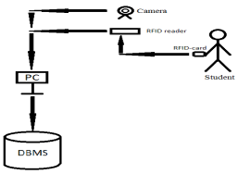

Figure 1: Architecture of the proposed system by Saparkhojayev & Guvercin (2012, p. 228)

The architecture of the proposed system can be seen in Figure 1. Their aim was to employ a centralized server connected to a single computer in each classroom, which would each in turn be connected to an RFID reader to read the student RFID cards, with a web camera also connected to the computer capturing a photo of the student on scanning (Saparkhojayev & Guvercin, 2012, p. 228). Similarly to the system proposed in this study, data is securely stored on the central server. Employing visual feedback forms a component of a two-step verification process, aligning with industry security standards. It shares the benefits of automation with the biometric system, lessening administrative workload. Crucially, it theoretically prevents buddy-punching and identity theft, the core problems with RFID-based systems. Although incorporating a web camera capable of capturing students faces in identifiable quality will no doubt add to costs of hardware and installation. Images captured by web cameras would also be freely available to view in case of a login breach, which may raise ethical or privacy issues. Alternatively, fingerprint templates can be stored in the database in any format as they do not need to be read by any party. The original format of the captured template allows for security measures such an encoding and encryption to ensure the raw data is only accessible to the fingerprint terminal.

Shende et al. (2014, p. 131) presents the concept of a multi-biometric system to avoid common spoofing techniques used to replicate biometrics and gain unauthorized access to systems such as the use of silicon, playdoh and gelatine to construct a spoof which can hold a real captured fingerprint.

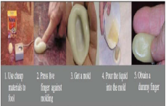

Figure 2: The process of creating a dummy finger (Shende et al., 2014, p. 130)

The process of creating the dummy finger is described in Figure 2. The finger to capture will be pressed to a mouldable material such as playdoh to form a mould. This mould can then be used to create a dummy finger. This is a common method used to gain unauthorized access to systems and is easier with the subject’s cooperation, although is possible without.

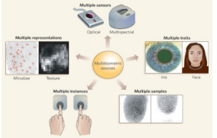

Figure 3: The various methods in implementing a multibiometric system as outlined by Shende et al. (2014, p. 131)

The several techniques outlined in the paper of implementing a multibiometric system are exhibited by Figure 3. Multiple instances in this context would refer to two fingerprints being required for verification from the same individual. This would necessitate the replication of multiple fingerprints from the same individual as fingerprints across the fingers of an individual generally differ, an extremely unlikely event given replicating a single fingerprint can be difficult. A drawback would be increased costs if multiple sensors are employed and double the storage space required to store fingerprint templates.

Another method can be multiple representations of the same fingerprint, such as the analysis of both minutiae and texture. Minutiae are finer details such as ridge endings used to differentiate fingerprints while texture refers to the overall pattern, the number of deltas, structure of the core etc. The analysis of multiple traits of the fingerprint ensures that spoofs are more unlikely to produce false positives. The multiple verification stages would however increase the sensor’s susceptibility to bad finger placement or fingers affected by skin conditions, while also slowing the process in an environment where registration must be quick and efficient. The high costs associated with sensors capable of such detailed analysis should also be considered. The integration of a multibiometric system can be cumbersome when balancing the strengths and weaknesses of each solution and should only be considered at institutions with high spoof rates. By testing in a live environment, the necessity can be effectively determined.

# Methodology

## Overview

This section will develop the proposal’s methodology in terms of research methods and technical aspects while acknowledging supervisor feedback left on the methodology. According to feedback, the research methods and technical aspects formed a well-organized and structured proposal, with the discussion of stages to split the workload required to meet the project aim and objectives being favoured by the supervisor. Furthermore, technical aspects were well discussed. This chapter will detail the specific aspects discussed previously which will be of use in this study. To view the full methodology, research question, aim and objectives, check Appendix A.

## Research Methods

Several research methods will be key in explaining the factors involved and determining the feasibility of a nationwide implementation of the system. Secondary data analysis, including analysis of details such as the national average digital literacy rate, can prove pivotal in gauging the acceptance of a new electronic system after a long dominance of the traditional methods, using statistical tools such as the R programming language to visualise the data and identify any insightful correlations or trends. Various packages offering functionality ranging from data visualization to machine learning contribute to R’s versatility. R will be used to create visualisations of the data to convey a more comprehensive message in the subsequent analysis. Metrics such as minimum/maximum values or averages will be calculated using built-in equations when importing the Comma-Separated Value (CSV) file into a Microsoft Excel spreadsheet. Primary data will also be collected post-implementation in the form of user feedback. Participants will be able to test the system upon providing consent and will be asked to perform basic everyday tasks that a member of staff would need to know how to complete in a live environment. Upon accomplishment of the tasks, they will be provided with a feedback form, containing questions about specific aspects of the system, such as the speed of fingerprint recognition as well as broader questions such as their opinion on future improvements to the system. All feedback forms completed by participants can be viewed in Appendix B. This utilisation of both quantitative and qualitative feedback will pave the way for further enhancement of the system’s user experience, security and performance. In the test validation stage, improvements will be made to the system based on user feedback, after evaluation of the feedback at the end of the implementation stage.

## Technical Aspects

Relevant technical aspects of the project include Windows Forms C#, the .NET framework, MySQL, Python, Raspberry Pi and the optical fingerprint sensor module. Windows Forms C# uses Microsoft’s .NET framework and therefore offers a range of functionality for developers, making it an industry standard for simple-purpose applications. The C# language is also compatible with a wide variety of libraries, ensuring integration with a local database will be straightforward. MySQL is one of the most popular SQL database management systems used in industry and suitable for running on a central server. Several cloud service providers also offer MySQL server functionality thereby simplifying the future process of migrating to the cloud. Python is a language with built-in support from the Raspberry Pi’s default Integrated Development Environment (IDE) and support from a wide range of libraries. Libraries will be used to enrol and compare fingerprints and to establish connection to the MySQL database in this project. The Raspberry Pi can theoretically be replaced with alternative microcontrollers and when implementing in a live environment, it is recommended when selecting both microcontroller and fingerprint module to undertake the appropriate research, balancing performance, power consumption and cost-effectiveness. The technical aspects of this project have been meticulously selected for their shared compatibility as well as their current uses in the industry and cost-effectiveness.

# Feasibility Study

## Overview

The feasibility study aims to determine the overall feasibility of implementing the biometric system on a national scale, through the analysis of existing secondary data, assessing feasibility from an economic and technical perspective, considering social or ethical issues which may undermine the initiative, discussing the various risks involved and how well the technology could be integrated with the existing systems of an institution.

## Analysis of Secondary Data

The internet hosts a vast amounts of data compiled by individuals, companies and governments. A subset of certain categories of data can be identified as relevant to this study and therefore suitable for analysis. These categories may include but are not limited to attendance rates, internet access and digital adoption rates in addition to environmental factors such as the increasing amount of plastic being transported to our planet’s oceans. Through examining the data, insight gathered may help determine feasibility. All analysed datasets can be found on [data.world](https://data.world/).

### Primary and Secondary School Attendance Rates

Current attendance rates can indicate fluctuations or flaws with the traditional methods of attendance-taking. These primary (Primary School Attendance | Data Mill North, 2021) and secondary (Secondary School Attendance | Data Mill North, 2021) school datasets contain attendance rates from over seven hundred area codes. Listed fields are shown below:



Figure 4: Fields present in attendance dataset.

Figure 4 displays fields of interest in the dataset. Lower layer Super Output Areas (LSOAs) consist of multiple Output Areas (OAs) which themselves represent a range between 40 and 250 households with a resident population between 100 and 625 persons, allowing LSOAs a range between 400 and 1200 households with a general resident population of between 1000 and 3000 persons, numbering 35672 across England and Wales (Census 2021 Geographies - Office for National Statistics, n.d.). The field ‘total_of_possible_sessions’ denotes the number of sessions which took place while ‘total_sessions_attended’ indicates the number of sessions attended. A session is outlined as half a day in the given context. In theory, it can be therefore assumed that in a hypothetical perfect attendance scenario, these numbers will be equal and in all other circumstances, ‘total_sessions_attended’ will be less than ‘total_of_possible_sessions’, with the difference designated by ‘total_sessions_missed’. Finally, ‘attendance’ identifies percentage rate of attendance by calculating attended sessions as a percentage of possible sessions.

The average attendance rate, calculated as approximately 95.71% for primary schools and 94.31% for secondary schools, indicating relatively high overall attendance although secondary schools are marginally lower. The secondary schools also have a greater distribution with the minimum value being 68.67% to the maximum value 100% against the 76.7% and 100% for primary schools, suggesting increased variability among LSOAs. One reason for this could be the wide dispersion in the sessions available across LSOAs with the least available sessions for secondary and primary schools respectively being 61 and 26, and the most available being 77,090 and 124,289. The wider range for primary schools here is attributed to their superior availability, with there being 20,806 primary schools to merely 4,190 secondary schools as of 2019/2020 (Key UK Education Statistics - BESA, 2021).

Provided these surface-level observations, it is possible to look further and identify patterns or anomalies with low or high attendance rates, providing insight as to where improvements might be needed and where the traditional system is working to an acceptable standard. This can collectively help in assessing any potential benefits of implementing a digital biometric system.

The below histogram visualises the distribution of attendance rates for the 2017/2018 academic year among secondary schools across England and Wales. Note that all visualisations were generated in RStudio (v2023.9.1.494; RStudio Team, 2020) using the Tidyverse library (v2.0.0; Wickham et al., 2019).

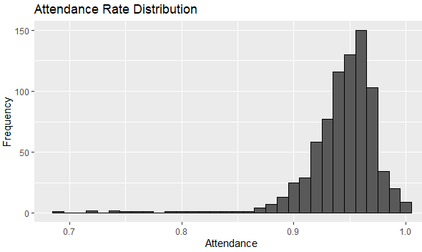

Figure 5: Attendance Rate Distribution histogram.

Figure 5 confirms that a majority of attendance rate figures from the LSOAs fall within the 90-100% range. This indicates that the percentage performance is generally high but not optimal as while the entries with lower rates are fewer in number, they do exist. The left end of the distribution extends past 0.7, signifying extreme outliers on the downside. Although the distribution greatly favours the upside, the broad range covered suggest that a subset of LSOAs experience major attendance issues, with a larger subset being affected by more minor attendance problems.

A proven way to measure distribution is to record the interquartile range of the dataset by subtracting the 25th percentile from the 75th percentile. Boxplots are common for expressing an interquartile range in visual form:

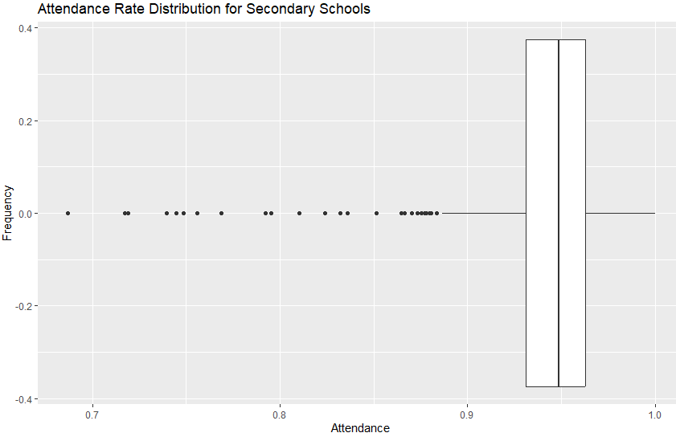

Figure 6: Attendance Rate Distribution boxplot.

Figure 6 presents the subset of LSOAs struggling with attendance issues clearly as outliers, while showing the range of most of the data relative to the median and upper and lower quartiles. The range confirms that the data is negatively skewed in relation to the median and therefore suggests greater variability as the rates get lower.

This establishes the foundation upon how the biometric system can pose a benefit by preventing manual mistakes, identifying and tracking the patterns of absentees in the lower attendance rate subset and the greater distribution can provide information on how to best allocate resources in mass implementation and which institutions require the most help.

### Internet Adoption

Observing the date at which a country opted to join the internet is a convenient method in determining how advanced the digital infrastructure is while being an indirect gauge of technological development. From this, conclusions can be drawn on how to best support such as system or if it is possible. The data (When Countries Joined the Internet - Dataset by Lukas, 2018) was compiled from individual records logged by the IANA WHOIS Service (Root Zone Database, n.d.), containing 245 countries and regions in the years between 1985 and 2011. Below see the fields of interest:



Figure 7: Fields present in internet adoption dataset.

The fields in the dataset are exhibited by Figure 7. The ’iso2c’ field designates each country and most dependent areas as a two-digit letter combination, ISO alpha-2 (Disclosure and Barring Service, 2018). The Country code top-level domain or ccTLD defines a domain name reserved for a country, generally identical to ISO alpha-2 with few exceptions such as ‘.uk’ domain for the UK despite an ISO alpha-2 of ‘GB’. The field in this context records when a country has registered for their national domain, regarded as when they started creating connections to the internet.

Through utilising the built-in Structured Query Language (SQL) editor on [data.world](https://data.world/), we can find the data for the UK.

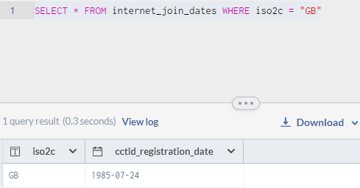

Figure 8: SQL query result.

Figure 8 shows the ccTLD registration date for the UK, one of the earliest countries in the world to adopt the internet, being also credited with the invention of the World Wide Web, a crucial component of the current internet. This strongly implies more advanced information technology infrastructure. The UK has also had abundant time for suitable regulations, such as data protection laws for example, to be introduced compared to other nations. Furthermore, an earlier adoption date could signify a higher national average digital literacy rate, therefore conveying a greater likelihood of acceptance in the event of a nationwide redesign of the attendance system.

### Internet Speed

A data visualisation recording the average internet speed across different areas of the country using the European Nomenclature of territorial units for statistics (NUTS) measurements commonly used in socio-economic analysis, defined as small regions for specific diagnoses (*Overview - NUTS - Nomenclature of Territorial Units for Statistics - Eurostat*, n.d.). Using the most precise form of NUTS measurement, NUTS-3, we can ensure the data can be used to cater to specific areas within regions of the UK rather than merely the broad regions. The data was collected by the European Data Journalism Network in 2022 using Speedtest by Ookla.

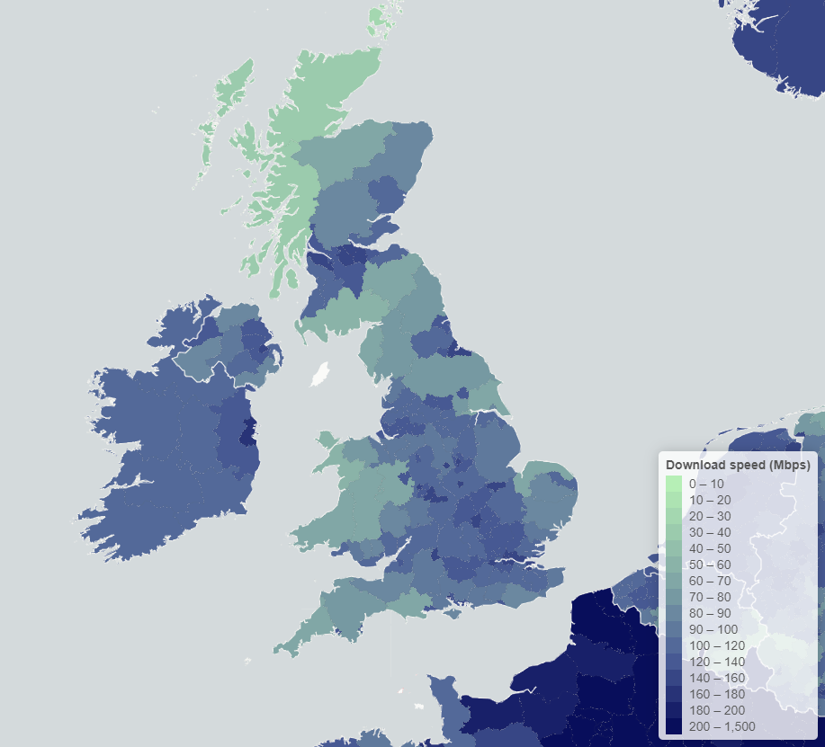

Figure 9: Average Internet Speed heatmap (Internet Speed in Europe, 2022).

Figure 9 presents areas varying by internet speed, grouped by colour. The areas with the highest internet speeds are approximately located in or near Greater London, Greater Manchester, the West Midlands, Merseyside and Durham/South Teesside. Wales is centred around Swansea while Scotland is centred around is largest cities, Edinburgh and Glasgow. Northern Ireland also has its greatest speeds in and around its capital region. The distribution of internet speed ranges across NUTS-3 areas appears wide when compared with northern France, indicating the funds required to build up the infrastructure for high-speed internet are allocated to the prominent population centres as France’s majority population is located north. This is emphasised by the sparsely populated areas displaying lower average speeds, for example the English-Scottish border region, Northern Scotland, and Wales excluding the southern coast.

Speeds exceeding 100Mbps are generally only required for niche purposes which consume bandwidth heavily, such as streaming video in Ultra High Definition (UHD) and online gaming. The system is extremely unlikely to bottleneck from internet speed issues and the range of 20-30Mbps should suffice. For certain institutions in less populated areas, measures should be taken to remove the cloud-based system in favour of an on-premise system.

## Assessment of Technical Feasibility

This section will investigate various technical variables involved in a successful implementation of a biometric system within the target environment.

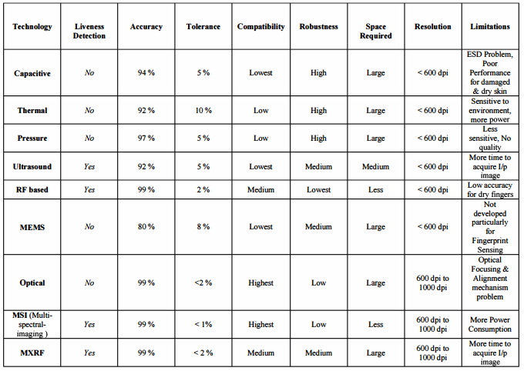Regarding software, fingerprint classification algorithms have been developed and implemented, improving on past generations over a time period spanning decades.

Figure 10: Comparison of fingerprint enrolment techniques (Ashwini et al., 2010, p. 173).

Figure 10 exhibits the properties of the known types of fingerprint enrolment techniques. The most commonly used in industry are capacitive fingerprint sensors for their anti-spoofing, and optical sensors for their high accuracy and adaptability to different skin conditions. Optical sensors are also able to capture in greater detail compared to many other types such as microelectromechanical systems (MEMS) or ultrasound. Ultrasound has the benefit of detecting liveness, albeit at an excessive opportunity cost when compared to simply using an optical sensor with a liveness detector.

The attendance management software needs to sport the basic functionality such as marking present or absent manually, searching for and filtering students, and generating analytic reports. Single-use codes may be shared with faculty to use for creating their login details. The codes will also be connected to an SQL server by institutional managers so this sensitive information cannot be accessed by lower faculty or students. It must also be Windows compatible. All login details and student fingerprints should be stored locally. The cloud could be used in conjunction with external security measures, notably the Advanced Encryption Standard (AES) and complex hashing algorithms, if the institution cannot accommodate the servers or network infrastructure. Network speeds should be greater than 25Mbps on average and MySQL should be used to communicate with the server over a segregated secure local network. All fingerprint clients, the database server and computers of trusted faculty members should be connected to this network.

In terms of hardware, fingerprint sensors are accessible due to the maturity of the biometric verification method in numerous industries. The R307 for example is an optical fingerprint sensor compatible with various microcontrollers such as Raspberry Pi and Arduino and only requiring 3.3V of electric potential. For optimal scalability, MySQL should be installed on dedicated servers managed by database experts however for smaller institutions, a local development machine should suffice. Microcontrollers capable of executing the necessary Python scripts should be placed in each classroom with few specialised enrolment terminals in central points throughout the institution. For power, wiring can be laid for each terminal. Alternatively, Raspberry Pi offers compatibility with both AA and rechargeable batteries, simplifying initial setup while necessitating routine checks on the power levels of the terminals. Eliminating background processes and ensuring only the necessary script is running will prolong battery life. For the simple function of the client-side script, using an older model Pi such as the 4 or 3 with a less powerful CPU would be beneficial if going this 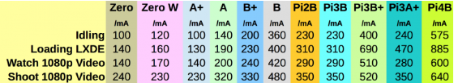route.

Figure 11: Power consumption across Pi models under varying stress levels (Alex, 2019)

Figure 11 shows Raspberry Pi 3 Model B requires 400mA for example while the Pi 5 could require greater than 1A With the ~50mA from the fingerprint module, total power consumption would be roughly 450mA, resulting in 4 hours of battery life with 6 AA batteries providing in the region of 2500mAh in a worst-case scenario although likely to be closer to 7 hours for this minimal use case. Rechargeable removable batteries should be sourced at around 10000mAh in capacity and, by initialising terminals only during academic hours, batteries have the potential to last a week, and can then be charged over the weekend. Electrical plug wiring, ideally out of view, is recommended.

## Assessment of Economic Feasibility

This section will discuss the potential economic impact associated with a successful implementation of a biometric system within the target environment.

Microcontrollers are often barebones in their functionality, possessing computing power incomparable to standard desktop computers, and therefore maintaining a low retail price in the range of £20-50. By taking the 3rd quartile of this range, we can calculate an upper estimate of £42.50, slightly higher than the Raspberry Pi 3 Model B retail price of approximately £40. A power supply for Pi 3 Model B maintains a retail price of £10. A basic fingerprint sensor with included socket header cables developed by Adafruit has a retail price of less than £20. This is due to the lower flash memory on the sensor, models with capability to house a thousand fingerprint templates will cost in the region of £60 per unit. For the purpose of this project, fingerprints will be stored in a database and flash memory will be used as temporary storage to compare two fingerprints, therefore nullifying benefits of more expensive models. The client hardware cost approximates to £72.50 per unit, although should be raised to £90 to accommodate the economic impact of batteries, casing or LED screens.

Class sizes in Britain’s schools have shown a marginal increase in recent years with the average class size of primary schools and secondary schools up to 26.7 and 22.4 in 2023, from 26.6 and 22.3 respectively in 2022 (Schools, Pupils and Their Characteristics, Academic Year 2022/23, 2023). Given secondary schools boast an average size of 965 pupils compared to 282 primary school pupils (Department for Education, 2019) , component costs will be significantly higher for secondary schools. Based on the rounded median of a sample size of 50 institutions for the academic year 2021/2022 (Statista, 2024), the average enrolment is 28,508 students, to 0 decimal places. Lecture hall capacity is widely known to be measured in hundreds, therefore as they vary, the optimal course of action would be to use a universal estimate. For the examples below, a capacity of 200 students will be used.

Equation 1: An equation calculating an estimate for the number of secondary school classes

$\frac{965 total pupils}{22.4 class size}=43.0803571=44 secondary classes (0 d.p.)$

Equation 2: An equation calculating an estimate for the total hardware component cost.

$44 classes ×£72.50 terminal cost=£3190 component cost$

$\frac{282 total pupils}{26.7 class size}=10.5617978=11 primary classes (0 d.p.)$

Equation 3: An equation calculating an estimate for the number of primary school classes.

$11 classes ×£72.50 terminal cost=£797.50 component cost$

Equation 4: An equation calculating an estimate for the total hardware component cost.

$\frac{28508 total pupils}{200 class size}=142.54=143 university classes (0 d.p.)$

Equation 5: An equation calculating an estimate for the number of university classes.

$$77 classes ×£72.50 terminal cost=£10367.50 component cost$$

Equation 6: An equation calculating an estimate for the total hardware component cost.

Equations 2, 4, and 6 show the estimated costs of hardware for secondary schools, primary schools and universities respectively, calculated in equations 1, 3 and 5 by dividing the total enrolment size by the average class size and multiplying the result by the estimated terminal cost.

Other areas contributing to initial cost should be considered such as servers to store the data locally and any networking equipment which will assist in forming a more robust local Wi-Fi network to maximise coverage. In scenarios demonstrating multiple concurrent queries, MySQL could benefit from a multi-core processor for moderate workloads. For a high volume of more complex queries, the processor should have a minimum of six cores. In terms of Random Access Memory (RAM), it also depends on the scale of the operation, as more RAM allows more data to be cached, consequently reducing use of the slower disk storage. For a smaller institution, a RAM capacity ranging from 8-16 GB should be sufficient. A database of a larger university however, containing tens of thousands of records, would undoubtedly gain from at least 32 GB. Solid State Drives would be preferable to the Hard Disk Drives (HDD) due to their faster access to data. The capacity should depend on the size of the database to be hosted, but a size of 256 GB for a moderately sized database should leave little else to be desired in this department, although the institutions themselves will be better informed upon making this decision. Both memory and storage should be easily upgradable to future-proof against subsequent rises in enrolment. Additional internal drives should be dedicated to routine backups. Gigabit Ethernet is recommended for a reliable network connection.

For the operating system, a Linux distribution, namely Debian or Ubuntu, will allow adherence to industry standards while maintaining a balance between stability, security and performance. This should run the latest version of MySQL to guarantee it receives new features, performance optimisations and security patches. The cost of the server will range from £1000-5000 depending on the institution’s requirements. The attendance management software could be developed internally by experienced software engineers, costing between a few thousand and tens of thousands of pounds, conditional on its complexity. Alternatively, this software could be created once by a central party, such as a company or the British government, and licensed to institutions for a small fee, which would pay for the database-related and software maintenance expenses. Initial installation costs could be as low as £3000 and as high as £15000 depending on the size of the institution, with around £500-5000 annually in technical support and £2000 in training. If batteries are used, installation will cost less, and yearly maintenance fees could instead rise. Monthly increase in electric and internet bills is projected to be marginal, less than £100 for a small to medium operation.

The low estimated initial investment cost is £13,000 with internal software and a £4700 annual fee covering maintenance, support, training and batteries. A high estimated initial investment cost will be £20,000 for servers and installation with £10,600 in technical support, training and software licensing fees. Usage of the cloud can compensate for lack of hardware investment, decreasing initial setup costs in inverse proportion to ongoing costs based on a pay-as-you-go model. Several larger corporations, notable Amazon and Microsoft offer high availability and scalability with their cloud services.

## Social and Ethical Considerations

The social and ethical concerns associated with implementing a biometric system provide a key method to determine public acceptance and therefore ensure the technology may be deployed in a responsible manner.

The ‘digital divide’ describes a phenomenon where categorical inequalities in society, typically attributed to gender, ethnicity or social class, resulting in an unequal distribution of resources, therefore meaning an unequal access to digital technologies, which then translates to unequal participation in society, reinforcing categorical inequalities and unequal distribution of resources in an endless cycle (Van Dijk, 2017, p. 3). Those without familiarity with fingerprint sensors may be alienated by replacing traditional methods with this advanced technology, exacerbating this divide. This is expected to primarily be an issue among younger target audiences and can be solved with proper instruction on how to operate the sensor.

Collecting and storing the biometric data of individuals, particularly minors, poses a privacy risk. If the database was to be breached, little would prevent personal data from falling into the wrong hands, potentially leading to identity theft, a reason for the system being implemented initially. A system using Role-Based Access Control (RBAC) with the principles of least privilege would ensure only people who require access to the database, such as technical support, can do so and appropriate security measures should be taken to render the data useless when stored except to the program, for example hashing algorithms. Using the modern concept of Multi-Factor Authentication (MFA) to combine the subject’s inherence, possession and knowledge (Carmel & Akila, 2020, p. 545), the risk of login misuse can be reduced. The cloud’s built-in security features may also be used. In addition, some may be uncomfortable with logging their biometric data, perceiving increased surveillance and contributing to a culture of mistrust. To combat this, options to opt-out should be considered, allowing willing participants to consent for use, while clearly defining the use case and ensuring these boundaries are not crossed.

Transparency in data use and associated safeguarding measures could also positively influence public trust in technology to perform this otherwise manually-performed task. When outlining this information, the system’s enhanced security, convenience and efficiency should also be communicated effectively.

The detection algorithm itself should not inherently disadvantage any individual or group, being engineered for versatility in a range of possible scenarios, such as wet fingers or chronic conditions such as atopic dermatitis affecting the hand particularly. It should however be noted that Godbole et al. (2022, p. 8) launched a study into demographic based biases in fingerprint recognitions systems which concluded that accuracy is inversely proportional to likelihood of bias and more importantly, the majority of observed demographic differentials can be attributed to poor quality of fingerprint images, leading to outliers in the genuine score distribution and therefore strongly indicating that differentials in fingerprint recognition performance between demographic groups are dependent on external factors unrelated to the demographic of the user.

## Risk Analysis

Several risks need to be identified and addressed to avoid more serious problems when implementing the system.

System failure is a possibility, where the system may not perform as expected due to hardware or software-related issues. A common method in mitigating the probability of this undesirable event occurring involves a testing phase, thoroughly evaluating that the performance of the system is what is expected. Software in particular should be predictable, consistent and offer no surprises to users, ensuring this can be made easier by using a software development lifecycle, such as the waterfall cycle to balance documentation and code, verifying that it behaves as specified, handles errors, and validates that the specification aligns with the user’s requirements (Singh & Singh, 2012, pp. 4-6). Routine checks may be of some benefit in confirming the software and hardware are to standard, the frequency of which are at the discretion of the institutions.

Resistance to adoption may be of concern, due to apprehensions relating to a breach of privacy or any setbacks that could be caused by adapting to a new system. This has the potential to hinder the effectiveness of the implementation and users should be trained on the system, and awareness should be brought to its security over its alternatives. Overreliance on external vendors to supply the critical components required can also cause progress to stagnate over the course of an implementation. Vendors should be well-diversified with an official list of trusted vendors being compiled. Alternatively, accountability could be considered by offering vendors contracts to build components to order, with a certain quantity to be delivered by a fixed date, which could also further streamline the process.

Chances that the system may not deliver expected returns on its initial investment once implemented are an important aspect to examine as the project would have wasted a significant amount of time and resources if it fails to improve efficiency and reduce costs by a distinguishable margin. Financial experts should conduct a comprehensive economic analysis before final approval and adjust their expectations accordingly when observing results in testing.

The system will be using a sizable amount of stored data to perform its day-to-day operations as well as conduct long term data analysis to find patterns and trends. In the event of system failure, this data would be lost in the absence of a recovery method, a recurrently approach in the industry being regular data backup options. The data should be encrypted prior to storage and the Diffie-Hellman approach (Kumar et al., 2012, p. 337) will allow shared keys to be used to then access the backup data in a remote facility if the data needs to be recovered while employing encryption in transit to reduce the risk of man-in-the-middle attacks.

**Diffie-Hellman**

Particular rational base point P, published in public domain for use with particular elliptic curve E(Fq), also published in public domain.

Person 1 and Person 2 choose random integers as private keys.

$\left\{ \begin{aligned}k_{A}→ k_{A}*P \\ k_{B}→ k_{B}*P \end{aligned}\right.$

These values are exchanged over an insecure network. Using this received information in conjunction with their private keys they can compute the following:

$$\left(k_{A}* k_{B}\right)*P= k_{A}*\left(k_{B}*P\right)= k_{B}*(k_{A}*P)$$

This value is now a shared secret only these 2 people possess. The nature of the equation ensures that the shared key is very difficult to compute given only kA * P and kB * P. Therefore, both private keys and the shared key are never shared over the network.

## Integration with Existing Systems

The level of integration with an institution’s existing systems and practices and the extent to which it could be achieved must not be overlooked and should be determining factor of the system’s feasibility.

With regard to programming languages, C# and Python strike the balance between performance and adaptability beneficial to this project. Both languages provide great versatility, and both offer compatibility with a wide range of services. For example, if the methods shown in this implementation are not optimal for the given context, the user may instead decide to opt for a RESTful Application Programming Interface (API) to facilitate communication between the monitoring software and the fingerprint detection script. The architecture presented in this project delineates the database as the intermediary between the client script and monitoring software, removing the necessity of direct communication. The C# application, if built using Windows Forms, a common method in the development of simple purpose applications, it will only be compatible with computers running the Windows OS (Operating System), although this may arguably be a minor sacrifice due to the wide range of tools and support that Microsoft’s .NET framework offers and their near-monopoly in the operating system market for personal computers, with their principal customers including OEMs (Original Equipment Manufacturers) and a vast majority of PC users having no commercially viable alternative. Furthermore, due to high barriers to entry (U.S. V. Microsoft: Proposed Findings of Fact, 2024), it is expected that Microsoft’s monopoly power will not diminish in the near future, ensuring that the attendance monitoring application will be available to its target audience.

MySQL is among the most popular Relational Database Management Systems (RDBMSs) used in the industry. This can be ascribed to the lack of costs associated with the software, being free, in addition to being open-source, being preferred for mission-critical applications due to its ability to preserve data integrity through elements such as atomic transactions, row-level locking and crash recovery, ensuring reliability in preventing data loss or corruption while also being highly scalable in handling large data collections through distribution over multiple servers (Šušter & Ranisavljević, 2023, p. 142). Institutions already require servers to hold student data, and many may already use MySQL. In these cases, only a slight alteration of the table to hold a fingerprint attribute and a new table for login details would be a prerequisite. MySQL is not a necessity, and the application may be updated to account for any RDBMS an institution may use, including those of the NoSQL variety such as MongoDB. Universities will also have extensive wireless network coverage to ensure that the database can be updated by a terminal regardless of its location on campus. For institutions lacking reliable network coverage, the cloud is recommended to allow connection to the database regardless of connectivity to other devices on the network on the condition that the given device is connected independently.

The placement of the fingerprint client terminal will be similar to the placement of ID card terminals currently for universities. In terms of wiring, the terminals should only necessitate power to be supplied and this can be done in a similar manner to currently, in accordance with the power usage requirements. For other institutions, this wiring will increase the costs of the installation.

## Conclusion

The secondary data analysis indicates that there is room for improvement in attendance scores nationally, that we are entering a digital age where the public rely on technology for day-to-day tasks and therefore high acceptance is projected, and that the nation supports the necessary infrastructure required to implement a biometric attendance logging system nationally. The assessments of technological and economic feasibility determine the types of technologies to use and how accessible they are, as well as outlining the core features the system should have as an improvement upon the traditional methods. The social and ethical consideration isolates the fundamental issues in our society and how the system could clash with the principles of data protection and right to privacy, detailing the course of action to minimise or negate the impact. The risk analysis recognises the most important risks associated with mass implementation, how they can affect involved parties and measures to prevent the risks from occurring. The system is also examined on its capabilities to pair with existing technologies that may be currently used by institutions.

On the conditions that the aforementioned security measures and data preservation arrangements are strictly implemented while educating the public on the system’s benefits over the previous methods and allowing any individual to withdraw or refuse consent to the use of their biometric data at any time, the system should be feasible. Extensive prior financial and logistical planning will also be necessary to ensure costs are kept minimal and implementation is efficient as possible. It should be noted that this feasibility study was performed using purely theoretical knowledge and practice in a live testing environment would yield more reliable results.

# Example Implementation

## Overview

This section will discuss the development of a basic biometric system to record and log attendance, consisting of three components. The client-side terminal will detect fingerprints placed on its sensor and update the attendance of the individual detected using their ID, designed for the students’ use. The desktop application will serve as a means to monitor both current attendance in real time and past attendance levels, while also existing as method in handling exceptions where the sensor is unable to detect a student, designed for faculty and administrator use. The client-side terminal and desktop application will be connected to a database, enabling the illusion of sharing data with one another without facilitating direct data communication or transfer.

All hardware and software utilised in the development of this system will be clearly outlined and the reasons for their use explicitly expressed. The code for all hardware and software can be found in Appendix C.

## Fingerprint Terminal

The fingerprint terminal will operate at the centre of the system architecture and will therefore be responsible for any real time issues that may arise. It must be ensured that the hardware components are compatible with each other as well as any existing libraries used in the script.

The hardware used for the purpose of this implementation consists of:

1 x [Basic Fingerprint Sensor with Socket Header Cable](https://www.adafruit.com/product/4690)

1 x [Raspberry Pi 5 Starter Kit](https://thepihut.com/products/raspberry-pi-5-starter-kit?variant=42614953115843) (Including

1 x Raspberry Pi 5 4GB Edition

1 x Raspberry Pi 27W USB-C Power Supply

1 x Raspberry Pi 5 Case (Red/White)

1 x SanDisk 32GB MicroSD card

1 x Micro-HDMI to HDMI cable)

1 x [USB to TTL Serial UART Cable Converter](https://www.ebay.co.uk/itm/203604196200)

The fingerprint sensor (Industries, n.d.) was selected based on its compatibility with a range of microcontrollers including the popular Raspberry Pi and Arduino and its integration with Adafruit’s CircuitPython library. The starter kit (The Pi Hut, n.d.) was selected due to bundling components needed to work with the Raspberry Pi such as the power supply and MicroSD card, while the case is optional. Finally, the Universal Serial Bus (USB) to Transistor-Transistor Logic (TTL) serial Universal Asynchronous Receiver-Transmitter (UART) converter (CP2102 Module USB to TTL Serial UART STC Download Cable Converter Adapter ESP826, n.d.) is required to transmit packets of data between sensor and microcontroller. Both sensor and microcontroller were purchased from Adafruit and official recommended vendor PiHut respectively.

When connecting hardware, the micro-High-Definition Multimedia Interface (HDMI) to HDMI cable enables connectivity to an external display to facilitate visual feedback in testing. In a live environment, no external display would be necessary as Light-Emitting Diode (LED) feedback is used to indicate successful scans or when the sensor is ready to scan however it can be coupled with a display if more indicative feedback is called for. The Raspberry Pi is connected to a mains power supply and a keyboard and mouse are also connected via USB for development and debugging purposes. Finally, the USB segment of the USB-TTL serial UART converter is connected to a USB port on the Pi, while the colours of the socket header cables with the sensor designate their pin positions on the opposing segment of the converter.

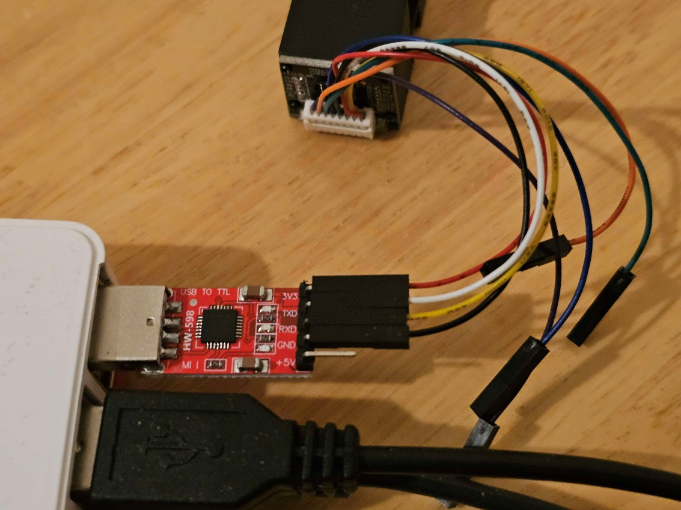

Figure 12: A close-up of the socket header cables connected to TTL serial UART

Figure 12 shows the order of connectivity to be adhered to when connecting the socket header cables, with the other end attached to the rear of the sensor. Black is Ground (GND), yellow to Receiver (RX), white to Transmitter (TX) and Red to 3.3 Volt (V) power as delineated by the sensor’s specification.

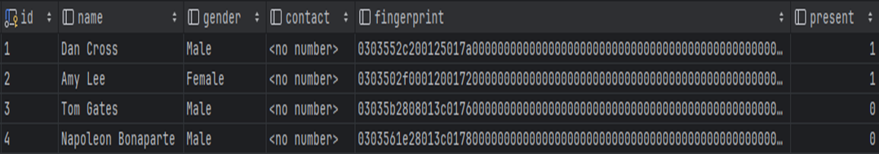Adafruit’s script provides sufficient capability in the enrolment, detection and deletion of fingerprint templates, therefore rendering it a viable option to form the foundation for the client-side script. By adapting the fingerprint_simpletest_rpi.py script found in the examples folder of the [Adafruit_CircuitPython_Fingerprint](https://github.com/adafruit/Adafruit_CircuitPython_Fingerprint/) GitHub repository, the file saving feature of fingerprint_template_file_compare.py could be incorporated and modified to store captured fingerprint templated to a MySQL database as an alternative to the sensor’s onboard flash memory or a local Text (TXT) file. The onboard flash memory has a limit of 300 templates and storing on both sensor and file mean that a fingerprint would need to be re-enrolled for every terminal. Fingerprints are stored in byte-array format; however, it was opted to convert fingerprints to hexadecimal format to allow for simpler database management processes. The resulting templates have a length of 1,500 characters, therefore approximating to 1,500 bytes (B) of storage per template. For a secondary school average estimation of 1,000 students, the storage required would be 1,500,000B, or 1.5 megabytes (MB). For 20,000 students, an estimate of the national average university enrollment, 30,000,000B, or 30MB required for fingerprint data.

Figure 13: Fingerprint template data as stored in the MySQL database.

Fingerprint template hexadecimal values are stored in a MySQL database as presented in Figure 13. When a template is detected by the sensor, a function is called within the Python script that updates the corresponding ‘present’ value from 0 to 1.

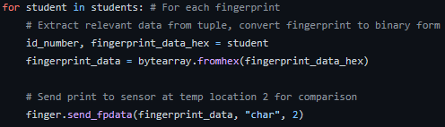

Figure 14: The comparison of all fingerprints in the table to the scanned fingerprint

Figure 14 shows the hexadecimal template converted to byte array before being temporarily stored on the flash memory of the sensor for comparison, for every template until a match is found.

## Desktop Application

The User Interface (UI) framework which was considered the most suitable for the development of a desktop application in the context of this study was Windows Forms, which itself is distributed through Microsoft’s popular .NET framework. Its ease of use will accelerate the development process and the comprehensive toolbox collection of elements offer great customisation potential for aesthetics and versatility in its functionality. These benefits are further compounded by leveraging the full capabilities of the .NET framework including a sizable base of active support and a modular design architecture.

The principal aim of this application is to provide a way to validate the correct real-time adjustment of attendance and handle any specific cases where the system may not work as expected. The frequency of these cases may largely depend on the progressiveness of the detection algorithms used and the type or quality of the sensors. The application must allow for a simple method of human intervention to correct any system faults without them affecting long term attendance analytics. In an optimal scenario, logging in to the application would be unnecessary as interruptions would not occur and the system would be fully automated. The secure login gateway is an integral part of the application and ensures that it adheres to strict data privacy guidelines in line with the principle of least privilege.

Secondary objectives for the system are to facilitate the transformation of collected data into viewable visualisations on an analytics page. The automatic generation of analytics was a key aspect of the non-intervention principle on which the system is based, allowing raw attendance data to be stored for a specified period of time following its collection to inform faculty members of absence patterns and certain frequencies in absence of individual students for example. The application would also need to uphold the standards of minimalism and simple navigation established by modern desktop applications.

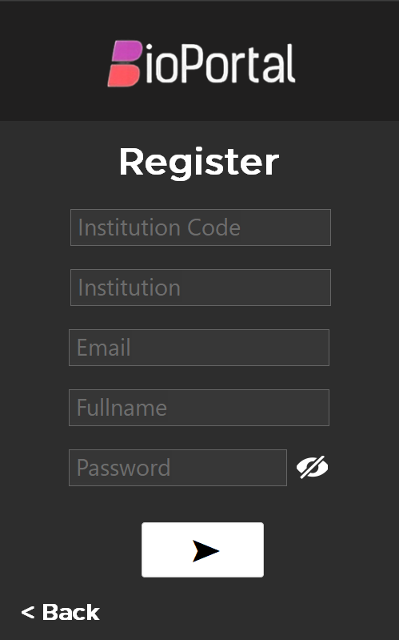

Figure 15: The register screen of the BioPortal attendance management system

The design language and colour tones are made apparent by Figure 15, which displays the screen users will need to navigate through to create their account. The choice of darker themes aligns with the aesthetic preferences of the wider population, and those preferred by heavy users. This is likely due to the reduced contrast provided by dark themes made further evident by the true black capability of OLED displays, reducing visual strain over prolonged periods while initially a concept introduced to tackle battery drain by increasing power efficiency (Eisfeld & Kristallovich, 2020, p. 17).

Institution codes in the given context would be distributed by the central authority which provided the software, as a method in validating the participating institutions. The lower-level faculty accounts would typically be managed in terms of establishing the connection to the onsite or cloud database by higher level faculty accounts, restricted in access to senior academic staff. Emails supply a means of data recovery which may be used for forgotten passwords, for example. Full names will identify faculty members within an institution’s database while the password is the instrument of control over an account with validation measures being implemented to ensure its integrity.

Figure 16: The method used to insert user credentials into the database.

Figure 16 shows credentials inserted into queries as parameters, ensuring inputs are managed as data.

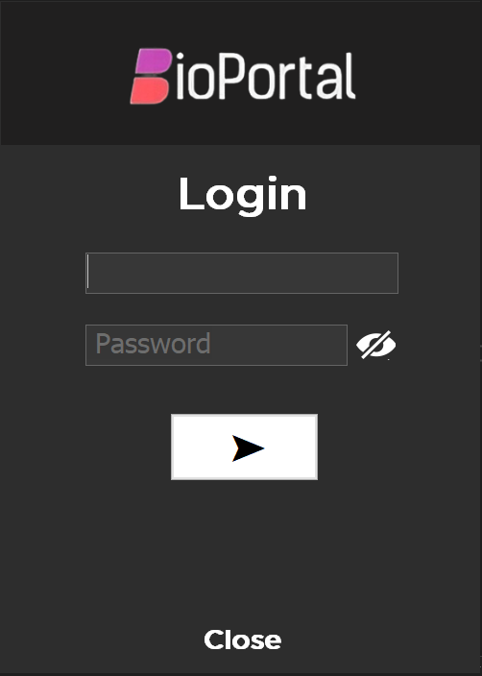

Figure 17: Login gateway of the BioPortal attendance management system

The login screen shown in Figure 17 takes a user’s email address and password as inputs and authenticates them using the stored credentials in the backend database. The toggler for show/hide password is a common occurrence in industry and enables simpler use of the application while maintaining its security.

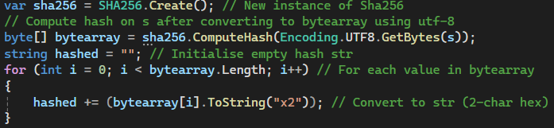It is widely considered a poor practice to store passwords in plaintext format. Cryptographic hashing algorithms perform an irreversible computation on the data, rendering it unrecognisable from its raw form. Dictionary attacks have seen a rise in their use in proportion to hashing algorithms, providing a method to breach accounts using more common passwords. A salt value appended to the password prior to hashing would require the salt to be found before a rainbow table could be used. Kumar et al. (2013, p. 433) describe rainbow tables as an exceedingly faster alternative to brute-force attacks and the most efficient method for cracking passwords. Ideally, a unique salt for each password would therefore require a new rainbow table to be compiled for each password.

Figure 18: Method used to hash the password.

The method used to hash the passwords is exhibited by Figure 18. After encoding the raw string, s, to byte array format through UTF-8 encoding, the hash can be computed which is also in byte array format. By iteration, each element of the byte array can be converted to string format while assigning two hexadecimal characters to represent the element. The value of hashed is now the hashed string.



Figure 19: Stored password in the database

Figure 19 shows an example password stored in the database. At the time of account creation, the NIST (National Institute of Standards and Technology) approved SHA-256 algorithm (Computer Security Division, Information Technology Laboratory, National Institute of Standards and Technology, U.S. Department of Commerce, n.d.) computes a hash value for the user’s chosen password. Amalgamated with a random alphanumeric salt generator of a random length, passwords can be stored with the security requirements demanded by the given context.

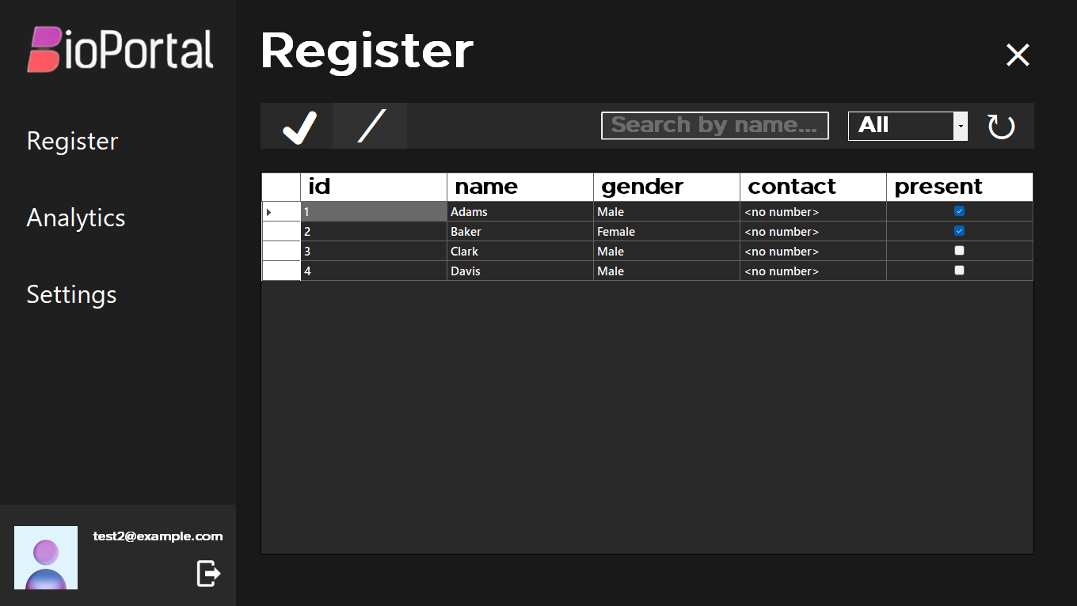

Figure 20: The main screen of the BioPortal attendance management system, to manage attendance if required.

Figure 20 illustrates the layout of the online register of the BioPortal attendance management system, with a purpose to resolve one of the main aims of the software by allowing faculty members to modify attendance values in real-time in the event of a system fault or failure. The toolbar above the register contains all the necessary controls for operating the system. From left to right, students can be marked present, absent, searched for by name, filtered by status of presence or absence and refreshed. The current version of the system updates a student’s status to present upon a successful scan, however the refresh button will be required to reflect this in the software. The option to mark present or absent represents the main intervention that would be needed by staff in a bad-worst case scenario and the two icons confirm their functions at a first glance. The search and filter options may seldom require use, however, should excel in their purpose in cases which necessitate a list of all present or absent students, or an individual student. Contact information displayed would usually be parental information provided in consent. Gender could potentially assist in correctly identifying a student in cases where a name may not be gender specific. The name field displayed in Figure 20 should contain the student’s full name for greater clarity in a live environment, having been only filled with single names for testing and demonstration purposes.

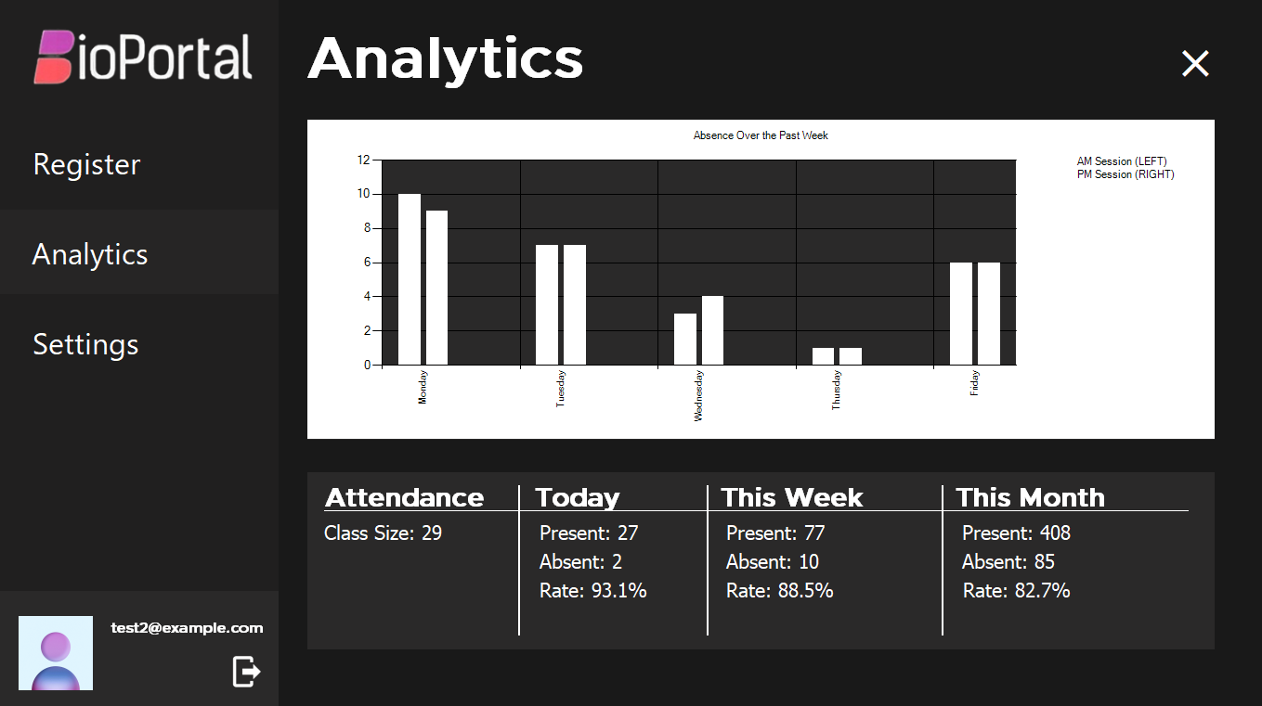

Figure 21: The analytics screen of the BioPortal attendance management system

The analytics screen as exhibited in Figure 21 provides a measure of absences throughout the past week. It does this by using a table with data which has been automatically collected and aggregated at the end of a week by taking a count of all students present and absent on the commencement of both sessions on each weekday. The chart element is used to convey this data in visual form, accommodating a simple process of identifying patterns and drawing insights. The analytics screen may be iteratively improved upon in a situation where a constant feedback source from live testing is available, adding further visualisations or more advanced metrics. The column chart utilises a prepopulated example table in Figure 21.

The attendance metrics shown in the lower segment of the analytics screen in Figure 21 can be used for inspecting attendance rates against the preset targets an academic institution may have, the data allowing limited insight into what could be causing an increase or decrease in attendance rate which may be identified with further analysis. As with the chart the metrics may likewise be adapted to find the most practical values to display in a live testing environment, however due to the extensive amount of data input required being inaccessible in the context of this implementation, the metrics in Figure 21 have been hardcoded to reflect values that could appear.

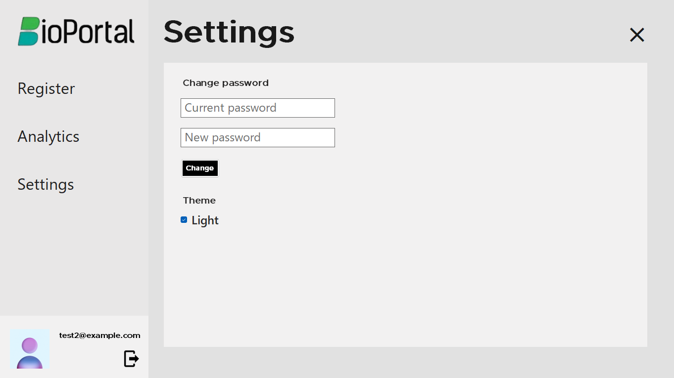

Figure 22: The settings screen of the BioPortal attendance management system

The settings screen as shown in Figure 22 is minimal, having two modifiable settings. It is important to allow users to change their password from their account if they know the original password. Specific cases where a user has forgotten their password will require the assistance of a higher-level management account to fix. In practice, a faculty member would need to contact the Information Technology (IT) support team based at their institution and they would need to reset the password, provide the faculty member with the dummy password and the faculty member could then go into the settings and change it to their desired password.

Figure 22 also showcases an alternative theme for a user-friendly application to users who may not prefer the default dark option. This allows users some customisability in how they want their interface to look aesthetically.

Overall, the BioPortal attendance management system has been able to achieve its primary goal of monitoring and modifying student attendance as well as its secondary goals of providing a simple and aesthetic user interface, credible password security and converting raw attendance data to a more easily interpreted visual form when needed through a limited scope of testing. Further testing using external participants will allow for a fairer test of its capabilities and outline any room for improvement.

## Local Database

For the purposes of this project and to maintain the privacy and confidentiality of test participants, a localised database is suitable for storing and managing student and faculty login data. Through establishing a connection with the database over a local network, the data can be made available to the program for manipulation and similar results can be expected as if a cloud database was connected to over the internet.

MySQL is generally regarded as a robust solution for the management of data in both small and large-scale contexts and is one of the most popular RDBMSs in the industry. For these reasons, it can be projected to deliver a seamless experience in accessing required data over a local network by multiple systems concurrently, as is the case with the discussed setup. Furthermore, MySQL is offered by many cloud providers such as Microsoft Azure (Azure Database for MySQL - Managed MySQL Database | Microsoft Azure, n.d.) and utilised by sizable technology corporations, ensuring the process of transferring to the cloud will not require the learning of unfamiliar rules or procedures.

When configuring the database, multiple tables required initialisation. The students, which in a live environment may either itself necessitate a multi-table setup or demand a field to differentiate between classes, would need to be stored with their names, IDs and biometrics. For the objectives of this implementation, the students table was split into two class sessions rather than a multitude of classes, AM and PM. This will showcase the system’s capability in a basic environment where more classes and layers may be added if the tests prove its proficiency in purpose. The ‘students’ resource is unique in that it is the only table that both the desktop software and client-side script require to function as intended. Logins will also need to be stored for the desktop application, with sensitive data such as the passwords stored in hashed format.

Some tables will not be dynamically updated at runtime by either system, serving to showcase certain aspects of the systems. The valid registered institutions taking part in the initiative should be stored by the managers and distributors of the software by only their name and a unique identifiable code assigned to them at registration. In addition, the attendance over the week stored the frequency of absences on each weekday and in a live environment with access to the compiled data, should update itself automatically, serving as the input source for the data visualised in the analytics section of the attendance management software.

## Evaluation of User Feedback

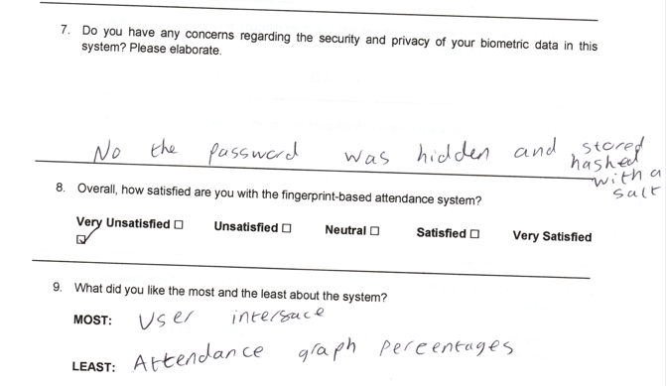The collection of user feedback can be of substantial benefit to this study, highlighting areas of the desktop application that are not user-friendly or intuitive and therefore providing insight on how the various processes can be adapted to ensure the system’s accessibility to a wide audience and general ease of use. The Participant Information Sheet (PIS), consent form and feedback form used for testing can be found in Appendix A, as well as all feedback of all participants. This section will select snippets of feedback to evaluate and review.

Figure 23: A snippet from the feedback form of Person 1 showing their concerns, satisfaction and what they liked the most and least.

Figure 23 outlines person 1 displaying considerable confidence in their data being secure during the time period it is handled and managed by the system, due to thorough security measures enabling the password to always remain hidden unless opted otherwise by the user and to never be stored in the database in its raw plaintext form. They are very satisfied with the system collectively and this could in part be caused by their familiarity with the UI, being mentioned as their favourite aspect. Lack of attendance metrics, particularly absence percentages was listed as a shortcoming of the system with the only percentage metric being the present rate necessitating mental calculations to be performed to obtain the absence rate.

The concern about the desktop application not providing sufficient data for regular day-to-day use in the analytics section is well founded, being a situation in which certain faculty members may struggle. An absence rate can be regarded as a vital piece of information as regular absences can lead to a decrease in classroom efficiency and overall learning progress. The participant also suggested an individual rate for each student, which would be practical in preventing a high absence rate from negatively impacting a student’s learning.

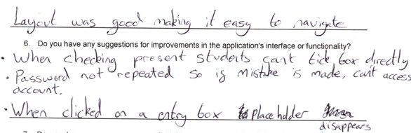

Figure 24: A snippet from the feedback form of Person 2 showing their opinion on the design/layout of the application, and improvement suggestions.

Figure 24 displays person 2’s positive thoughts regarding the UI design of the desktop application and their suggestions for areas of improvement. The layout was described as ‘good’ and therefore ‘easy to navigate’ which was the principal goal in designing the layout for the application to ensure it could be widely used by staff nationally. Easy navigation forms a cornerstone for modern UI design, allowing any page or function the user wills to be located with relative ease. When asked about improvements, they mentioned a few of the more questionable design choices from their point of view, mentioning that toggling the tick box should be the default method for marking students present or absent. They also mentioned that when changing their password, they were only prompted to enter the current password and new password without confirmation of their new password, which could lead to users getting locked out of accounts in their opinion. The placeholder prompting the data to enter into entry boxes also disappears on selecting these boxes which can lead to confusion.

While toggling the tick box may be the first instinct of the user, an issue like this is unlikely to cause persistent problems as the process has been simplified to where once the user has learned the function, they will not be quick to forget. No user will be expected to pick up the workings of the software on their own and training will inevitably be provided and there is therefore no benefit in updating this functionality at the current stage. The lack of confirmation of passwords however poses a significant inconvenience to the user, and technical support teams in the event of a lockout and steps should be taken to reduce this risk. The lack of labels for input fields is also an unnecessary design choice offering no benefit while increasing the complexity in using the application.

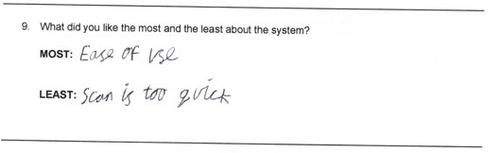

Figure 25: A snippet from the feedback form of Person 3 showing their most liked and least liked aspect of the system.

Person 3 supplies compelling feedback as shown in Figure 25. Uniformly to previous participants, the simplicity in the use of the application is described as their favourite feature while their least favourite feature is unheard of so far from other participants. This particular participant was having trouble scanning their fingerprint due to the sensor capturing their fingerprint image before their finger was placed on the surface. The participant mentioned how adding manual delay to the scanning process would prevent certain cases where students would be unable to scan their print, necessitating human intervention.

The addition of this delay to the program, while marginally slowing down the scanning process, can be a beneficial asset in preventing unintended consequences posed by the system’s implementation in a live environment.

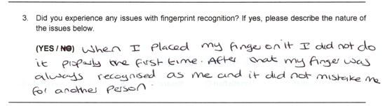

Figure 26: A snippet from the feedback form of Person 4 outlining their interaction with the fingerprint recognition aspect of the system.

Figure 26 presents person 4 recounting their experience when operating the fingerprint sensor. They praised the algorithm’s ability to differentiate between people and even individual fingers of the same person. They did initially have a problem with the sensor not being able to identify their fingerprint features but were however able to resolve this without outside intervention with the use of an alternate finger, attributing it to their finger placement on the scanner’s surface during enrolment. Nevertheless, this participant suffers from skin conditions affecting the skin on their fingers and fingertips specifically and this is more likely to be the problem. The participant therefore belongs to a group of people who were projected to have a greater likelihood of encountering issues with fingerprint recognition earlier in this study.

The sensor did perform exceptionally well during subsequent scans once the fingerprint template had been stored for comparison and therefore any problems during scanning are unlikely to occur with the issues introduced above only present during enrolment and can be rectified by the user with a fairly low amount of effort.

## Conclusion

While the system may have several minimal design flaws and issues with the speed and accuracy of the sensor during enrolment, the feedback will be an important asset in its continued improvement. Through minimising and resolving these negative observations, the system’s integrity and ability to perform in live fast-paced environments can be preserved.

For the link to the GitHub repository associated with this implementation of the biometric attendance management system as well as the link to the demonstration video showcasing all aspects of the system, check Appendix B.

# Results

This section will summarise the findings from the feasibility study and example implementation before delivering a final verdict on how fingerprint attendance systems compare to traditional methods in performance, security and user experience as well as the feasibility of a nationwide adoption.

The secondary data analysis section of the feasibility study found that a biometric system can be expected to improve attendance rates on a national scale by removing inaccuracies and inconveniences associated with the traditional methods. The human error from both teacher and students present in roll calls is eliminated. Additionally, ID cards pose the constant risk of buddy punching and identity theft compromising the integrity of attendance records. The utilisation of fingerprints introduces a unique element to registering attendance, thereby resolving these issues and allowing the system to deliver greater performance as a tool to register and monitor attendance in relation to the traditional methods.

This also contributes to a more secure environment where only the subject of the attendance record can verify their attendance, provided sufficient measures are undertaken to protect the biometric data of students while stored and maintained in the system database. Conversely, the potential for lost or stolen ID cards undermines the security of RFID tags while it is made easy for one student to respond on behalf of another during roll calls, taking their identity to falsify their presence. Overlap is present with regards to the security of the attendance monitoring software and steps should be taken to ensure that it is only accessible to authorized persons by maintaining robust security protocols that may already be in place under the current system at select institutions, such as password validation and two-factor authentication (2FA).

In terms of user experience, testing has shown that users can generally enrol and verify their fingerprints without issues excluding edge cases concerning people who aren’t as digitally literate or have skin conditions affecting the fingers. Users have also found the attendance monitoring software easy to navigate and had no difficulty locating required information or performing tasks using the software. Omitting the possibility of misplacing ID cards, minimal user experience benefits such as a marginal time decrease can be observed in comparison with the current system in universities. A more significant time difference is perceived when compared to the roll call.

The infrastructure of the nation supports the possibility of a nationwide adoption, and it may be a viable option in the future under strict privacy and security regulation and funded training programs for the adjustment period. Be that as it may, this may not be the optimal course of action at present, due to the inability of optical sensors to detect fingers afflicted by skin conditions such as eczema, which would bar certain people from being able to take part. When more advanced sensors are available at cheaper rates, this will become less of an issue. Many individuals might also express reluctancy in consenting to the use of their biometric data, necessitating alternate systems to be implemented. One possible method could be to have an option for the student enter their ID instead of scanning their fingerprint on the same terminal.

Altogether, while the system carries numerous advantages in performance and security, several issues holding it back need to be addressed before considering a nationwide adoption. More innovation and higher digital literacy are projected for the future in the west. Future technology and societal culture could enhance the system’s capabilities beyond examples seen in this study.

# Discussion

## Test Validation

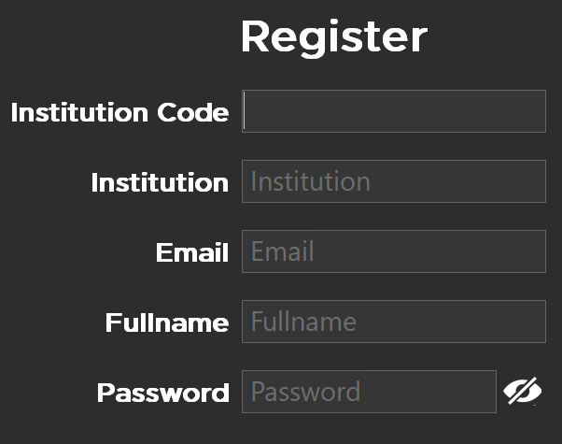This section will investigate the issues found in the testing stage and propose a solutions for several of these issues, explaining the justification for each.

Figure 27: A screenshot of the input fields on the register screen.

The updated input fields are as follows in Figure 27, to address the issue of placeholder text disappearing as it has above. It is shown that even though the text has disappeared, the label will remain as guidance for what is expected to be inputted into that field. This was opted to emulate the simplicity of modern software applications as labels are an integral part of a login or register screen to avoid confusion in these areas.

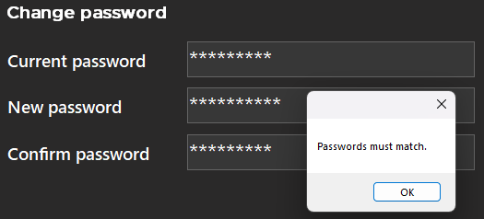

Figure 28: A scenario where the correct current password is entered but the new password does not match the confirmation.

Figure 28 shows the label text for the input fields displayed on the settings page as well as another change. The new password must be confirmed each time a password is changed, which was a change suggested by a participant during the feedback review to avoid the possibility of accidental password changes resulting in account lockouts.

## Project Management

Sensitive biometric data was only ever stored temporarily in the sensor’s flash memory or in the local database, made accessible to only the principal investigator as well as the information of test participants. Participants were never asked for data not deemed necessary. Participants were asked to use dummy credentials when registering their account on the software. Participants were encouraged to freely express their thoughts through feedback. Records of participant consent forms and feedback were kept confidential and in a physically secure manner. Participant documents were scanned to include in this document, barring their personal information. All participants were numerically anonymised in this report. In the period between their scanning and the completion of this report, records were stored using Coventry University OneDrive. All user data will be securely destroyed on the 1st December 2024.

I engaged with supervision through regular weekly meetings with my supervisor, where I would actively seek feedback in the form of their opinion on choices made throughout the project and considering this feedback when updating the report. Achievable and explicit objectives would be set for each week where I would share my progress the following week.

Time and resources allocated to the project were managed through the assignment of weekly goals. The Gantt chart (see Appendix A) was employed as a tool to plan the methodology and the project was split into four stages, the literature review/secondary data analysis, hardware assembly, database configuration and application development. Rather than the four sequential stages, I found that the process was simplified when setting particular goals for each stage, facilitating the concurrent completion of each stage. This meant I could use insight from the current progress of one stage when working on another stage. For example, I was able to integrate the MySQL database when working on the client-side script as the database had already been configured and was the likely choice for a localised storage method. R was selected to analyse the data due to my pre-existing familiarity with the language and ‘Tidyverse’ library although similar results could be expected when using the Python ‘pandas’ library for example. Through this, visualisations were able to be created in line with the project’s goals. MySQL was used due to its popularity and ease of integration with the established systems used, the client-side Raspberry Pi script and C# desktop application.

## Reflection

In terms of the objectives, an extensive literature review has been conducted based on papers regarding the wider field of biometrics and fingerprint identification as well as papers focusing on the implementation of a biometric system. Biometric detection hardware was assembled using a microcontroller with a fingerprint recognition module with the onboard script fully capable of enrolling and recognizing the fingerprints of students and updating their attendance in the database. MySQL was employed as a cloud substitute to prevent ethical issues with participant data being stored with a third party and as a solution, has demonstrated cost-effectiveness and is scalable in modern enterprise applications. A desktop application has been designed and implemented employing stringent security measures to protect the data of staff and students. Legal, social and ethical concerns have been addressed in the feasibility study. Finally, the new system has been compared to the traditional methods in terms of security, performance and user experience and the question of whether a mass implementation is feasible has been answered.

The project has fulfilled its aim to an extent. A biometric system using fingerprint detection has been developed, with connection to data systems in popular current use for real-time monitoring and its efficiency assessed through testing. Nevertheless, the environmental impact of implementing the biometric system was unable to be measured due to the lack of sufficient data.

Contributions to the field of biometrics cannot be understated. The methodological practices employed when handling the sensitive biometric data of individuals serve as a blueprint for future studies where the collection of personal and identifiable data is concerned. The speed, accuracy and reliability of optical fingerprint sensors under varied circumstances has been closely tested for any shortcomings which may hamper its ability to perform as expected in a live environment and the findings could be beneficial to future studies looking to investigate alternative types of sensors and the benefits, drawbacks and scenarios discussed in the literature review can help make an informed decision concerning the use of different biometric types such as the face or iris. The principles of professionalism and minimalism adhered to by the desktop application will prove constructive to future user interface development.

The scope of this study is constrained by several limitations. As mentioned previously, insufficient data is available to meet the full aim of the project. A key limitation concerning fingerprint recognition is the types of fingerprint sensor covered as the speed, accuracy and reliability can vary greatly between types especially in separate environments. This study focuses on optical sensors due to their cost-effectiveness but in the future, capacitive sensors which use electricity to determine fingerprint patterns and ultrasonic sensors which have been prototyped in high-end flagship smartphones (Uchenna et al., 2020, p. 3) may become more affordable as technology progresses. A further limitation is the necessary adherence to the appropriate ethical guidelines preventing the integration of cloud technology to store the data.

Investigators who could provide suitable answers to ethical questions that may arise from storing sensitive data with a third party may use this project to explore possible solutions for hosting a database in the cloud as the infrastructure required for the robust local network necessitated by a localised MySQL database may not be supported by certain academic institutions. In performing this task, they will need to find measures of interacting with cloud services in a secure manner (Syed et al., 2020). Researchers concerned about the performance of the optical sensor used in this study would be welcome to attempt to collect more promising results using variant sensor types (Uchenna et al., 2020) or consider fingerprint image enhancement techniques (Pakutharivu & Srinath, 2015, p. 4) to improve the reliability of an optical scanner.

# Conclusion

When reviewing the aim of this study, to employ biometric techniques to register attendance to ensure the reliable identification of students and prevent false negatives and false positives occurring through human error, the performance of the biometric system and benefits of automation have been demonstrated, while evaluating the current possibilities of optical fingerprint sensors to replace the traditional attendance registration methods. It was found that affordable optical sensors without image enhancement were inferior to current methods in terms of inclusivity, although this is subject to change with future developments and alternative capacitive or ultrasonic technologies. These insights will not only allow a greater understanding of the wider field of biometrics in terms of its use in different contexts but should elicit re-evaluation of current methods to resolve issues surrounding these techniques.

## Future Recommendations

Although the study is limited to the data available for analysis, optical fingerprint sensor technology, lack of testing in a live environment and an inclination to adhere to the appropriate ethical standards and guidelines, it may lay the foundation for future work concerning cloud integration and the performance of different sensor types and algorithms on a diverse set of people.

The current implementation would see benefit from testing in a live environment as the potential issues that could arise would be identified and could then be resolved. If the system performs as expected multiple classes and individual lessons instead of AM and PM sessions could be integrated as well as management accounts. The automation aspect of the system could be enhanced through the implementation of features such as utilising the stored contact information of students to automatically text parents or guardians to notify them of either a single absence or a string of absences.

# References

Patel, U. A., & Priya, S. (2014). Development of a student attendance management system using RFID and face recognition: a review. *International Journal of Advance Research in Computer Science and Management Studies, 2(*8), pp. 109-119.

Saparkhojayev, N., & Guvercin, S. (2012). Attendance Control System based on RFID-technology. *International Journal of Computer Science Issues (IJCSI), 9*(3), pp. 227-230.

Shende, P. M., Sarode, M. V., & Ghonge, M. M. (2014). A survey based on fingerprint, face and iris biometric recognition system, image quality assessment and fake biometric. *International Journal of Science, Engineering and Computer Technology, 4*(4), pp. 129-132.

*Primary school attendance | Data Mill North.* (2021, August 4). <https://datamillnorth.org/dataset/20zyk/primary-school-attendance>

*Secondary school attendance | Data Mill North.* (2021, August 4). <https://datamillnorth.org/dataset/2nxry/secondary-school-attendance>

*Census 2021 geographies - Office for National Statistics.* (n.d.). <https://www.ons.gov.uk/methodology/geography/ukgeographies/censusgeographies/census2021geographies#lower-layer-super-output-areas-lsoas>

*Key UK education statistics - BESA.* (2021, July 2). BESA. <https://www.besa.org.uk/key-uk-education-statistics/>

RStudio Team. (2020). *RStudio: Integrated Development Environment for R*. Retrieved from <http://www.rstudio.com/>

Wickham, H., Averick, M., Bryan, J., Chang, W., McGowan, L., François, R., Grolemund, G., Hayes, A., Henry, L., Hester, J., Kuhn, M., Pedersen, T., Miller, E., Bache, S., Müller, K., Ooms, J., Robinson, D., Seidel, D., Spinu, V., … Yutani, H. (2019). *Welcome to the tidyverse*. Journal of Open Source Software, 4(43), p. 1686.

*When Countries Joined The Internet - dataset by lukas.* (2018, February 7). data.world. <https://data.world/lukas/when-countries-joined-the-internet/>

*Root Zone Database.* (n.d.). https://www.iana.org/domains/root/db

Disclosure and Barring Service. (2018, May 1). *ISO Country Codes*. GOV.UK. <https://www.gov.uk/government/publications/iso-country-codes--2>

*Overview - NUTS -* *Nomenclature of territorial units for statistics - Eurostat*. (n.d.). Eurostat. <https://ec.europa.eu/eurostat/web/nuts/overview/>

*Internet speed in Europe*. (2022). <https://datavis.europeandatajournalism.eu/obct/connectivity/>

Ashwini, B., Digambarrao, J. S., & Patil, S. P. (2010, August). Performance analysis of finger print sensors. In *2010 2nd International Conference on Mechanical and Electronics Engineering*, Vol. 1, pp. 169-174. IEEE.

*Alex. (2019, June 25). How much power does the Pi4B use? Power Measurements.* RasPi.TV. <https://raspi.tv/2019/how-much-power-does-the-pi4b-use-power-measurements>

*Schools, pupils and their characteristics, Academic year 2022/23.* (2023, June 8). [https://explore-education-statistics.service.gov.uk/find-statistics/school-pupils-and-their-characteristics#dataBlock-ff26cc29-59eb-4e31-ae5c-0918b056d599-tables](https://explore-education-statistics.service.gov.uk/find-statistics/school-pupils-and-their-characteristics%23dataBlock-ff26cc29-59eb-4e31-ae5c-0918b056d599-tables)

Department for Education. (2019, June 27). *Schools, pupils and their characteristics: January 2019* [White paper]. GOV.UK <https://assets.publishing.service.gov.uk/government/uploads/system/uploads/attachment_data/file/812539/Schools_Pupils_and_their_Characteristics_2019_Main_Text.pdf>

Statista. (2024, February 5). *Universities with the highest number of students in the UK 2021/22*. https://www.statista.com/statistics/1168605/largest-universities-in-the-uk/

Van Dijk, J. A. (2017). Digital divide: Impact of access. *The international encyclopedia of media effects*, pp. 1-11.

Carmel, V. V., & Akila, D. (2020). A survey on biometric authentication systems in cloud to combat identity theft. *Journal of Critical Reviews, 7*(03), pp. 540-547.

Godbole, A., Grosz, S. A., Nandakumar, K., & Jain, A. K. (2022, October). On demographic bias in fingerprint recognition. In *2022 IEEE International Joint Conference on Biometrics (IJCB),* pp. 1-10. IEEE.

Singh, S. K., & Singh, A. (2012). *Software testing*. Vandana Publications.

Kumar, A., Lee, B. G., Lee, H., & Kumari, A. (2012, October). Secure storage and access of data in cloud computing. In *2012 International Conference on ICT Convergence (ICTC),* pp. 336-339. IEEE.

*U.S. v. Microsoft: Proposed Findings of fact. (*2024, January 24). <https://www.justice.gov/atr/us-v-microsoft-proposed-findings-fact-0>

Šušter, I., & Ranisavljević, T. (2023). Optimization of MySQL database. *Journal of process management and new technologies, 11*(1-2), pp. 141-151.

Industries, A. (n.d.). *Basic fingerprint sensor with socket header cable*. <https://www.adafruit.com/product/4690>

The Pi Hut. (n.d.). *Raspberry Pi 5 Starter Kit*. <https://thepihut.com/products/raspberry-pi-5-starter-kit?variant=42614953115843>

*CP2102 Module USB to TTL Serial UART STC Download Cable Converter Adapter ESP826.* (n.d.). eBay. https://www.ebay.co.uk/itm/203604196200

Eisfeld, H., & Kristallovich, F. (2020). The rise of dark mode: A qualitative study of an emerging user interface design trend.

Kumar, H., Kumar, S., Joseph, R., Kumar, D., Singh, S. K. S., Kumar, A., & Kumar, P. (2013, April). Rainbow table to crack password using MD5 hashing algorithm. In *2013 IEEE Conference on Information & Communication Technologies*, pp. 433-439. IEEE.

Computer Security Division, Information Technology Laboratory, National Institute of Standards and Technology, U.S. Department of Commerce. (n.d.). *Hash Functions | CSRC | CSRC.* <https://csrc.nist.gov/projects/hash-functions>

*Azure Database for MySQL - Managed MySQL Database | Microsoft Azure.* (n.d.). <https://azure.microsoft.com/en-us/products/mysql/>

Uchenna, E. N., Raphael, O. O., & Leonard, A. T. (2020). Overview of technologies and fingerprint scanner used for biometric capturing. *Innovation, 1*(1), pp. 1-5.

Syed, A., Purushotham, K., & Shidaganti, G. (2020, November). Cloud storage security risks, practices and measures: A review. In *2020 IEEE International Conference for Innovation in Technology (INOCON),* pp. 1-4. IEEE.

Liu, J. K., Liang, K., Susilo, W., Liu, J., & Xiang, Y. (2015). Two-factor data security protection mechanism for cloud storage system. *IEEE Transactions on Computers, 65*(6), 1992-2004.

Pakutharivu, P., & Srinath, M. V. (2015). A comprehensive survey on fingerprint recognition systems. *Indian Journal of Science and Technology.*

# Appendices

## Appendix A

  
Individual Project Template

*This document is intended for Coventry University Group students for their own use in completing  
their assessed work for this module. It must not be passed to third parties or posted on any website.*

# Project Information

11068789

Asim Adalat

**Student:** ________________

Dr Katerina Stamou

**Supervisor:** ________________

**Student ID:** ________

P167321

**Ethics Number:** ________

# Project Declaration

I declare that this project is my own original work; I have not copied or adapted any part of it from another source except where clearly acknowledged with both in-text citations in the main text of the report and complete references.

I confirm that I have submitted a proposal for ethical approval through [ethics.coventry.ac.uk](https://ethics.coventry.ac.uk) and have included the ethics case number above (Example. P143576). Projects without a valid ethics case number will not be accepted and will not be marked.

I understand that the copyright for this project report and any product developed as part of the project belong to Coventry University. Support, including funding, is available to commercialize products and services developed by staff and students; revenue generated is split with the inventor(s) of the product or service. Further information is available at [www.coventry.ac.uk/ipr](http://www.coventry.ac.uk/ipr) or <mailto:ipr@coventry.ac.uk>.



**Name:** ________________



electronic signatures are acceptable

26/11/2023

**Date:** __

6000CEM – Individual Project Preparation

Individual Project Proposal

Fingerprint Attendance Technology: Revolutionizing Academic Tracking and Security in the Education Sector

Name: Asim Adalat

Student Identification No.: 11068789

Supervisor Name: Dr Katerina Stamou

Ethics Reference No.: P167321

**Table of Contents**

Project Information 38

Project Declaration 39

Introduction 42

Abstract 42

Aim and Objectives 42

Research Question 43

Literature Review 44

Overview 44

Background 44

Reported Benefits, Challenges and Outcomes 45

Comparative Analysis of Biometric Types 46

Technological Considerations 47

Methodological Approaches 48

Ethical and Legal Factors 48

Conclusion 49

Research Methods 52

Technical Aspects 54

Overview 54

Data Analysis 54

Hardware 54

Fingerprint Verification 54

Database Emulation 55

Languages and Frameworks 55

Appendix A 56

Appendix B 60

References 63

# Introduction

## Abstract

Attendance needs to be monitored for academic institutions to track students’ whereabouts for their safety, to provide insight into who needs early intervention or even to reward students for perfect scores, instilling traits like discipline and timekeeping during their formative years.

The 21st century undergone an increase in the range of advancements from the smartphone industry to augmented reality and their effects are shown in the classroom. Students can learn in a more engaging manner, playing educational games on interactive smartboards and teachers have greater resources at their disposal while planning lessons on the web. The traditional roll call system for taking attendance originates in the medieval era, as a list of names bound into a scroll and has become an integral part of our society notably in law enforcement buildings, military posts and voting assemblies. Roll calls have remained unchallenged due to their simplicity– it just works, and everybody can be trained to get involved with it. Is it possible to replace this procedure with a new system sharing the comprehensibility of the old while seamlessly integrating with the electronic systems of the 21st century?

Biometrics have become prevalent in protecting user security through using for example faces and fingerprints to login. Biometric systems take advantage of a user’s unique physical features by scanning them using various technological approaches to verify it is them attempting to login, ranging from analysing the characteristics of the iris to analysing the patterns of the veins in the palm of their hand. Among numerous advantages of biometric systems are their timesaving capabilities, not being necessary to memorise several complex passwords and the accuracy of their results.

## Aim and Objectives

The project aims to utilise biometrics to record attendance, optimising the process by ensuring reliable identification of students and eliminating the false positives and negatives caused by human error. It could make ID cards redundant, reducing plastic usage causing a positive environmental impact whilst removing the event of students signing other students in and factoring out the possibility of students misplacing ID cards.

The main objectives are:

* Perform an extensive literature review of current papers in the wider field of biometrics to draw comparisons with similar projects and weigh their benefits and drawbacks.

* Build biometric detection hardware by connecting microcomputer with fingerprint module and develop on-board code to enroll and recognize fingerprints, prioritizing real-time accuracy.
* Run database emulator on local machine to demonstrate cost-effectiveness and scalability while avoiding ethical challenges of storing data with a third-party
* Design secure desktop application for institutions to monitor attendance. Integrate to work seamlessly with microcomputer and database.
* Evaluate biometric system against traditional methods, addressing legal, ethical and security concerns.

## Research Question

Therefore, the research question to be answered is: “How do fingerprint attendance systems compare to traditional systems with regards to performance, security and user experience, and is a nationwide adoption feasible?”

# Literature Review

## Overview

This chapter includes review on the strengths and weaknesses of the different approaches presented in other studies and reports will be discussed, their methodologies and findings summarised, and any reported outcomes of the adoption of fingerprint scanners in academic institutions will be evaluated. A variety of data collection and analysis techniques may also be assessed.

Numerous alternative biometric methods of taking and monitoring attendance will be contrasted against the fingerprint system paired with a local database and desktop app in terms of accuracy, efficiency, and security and both the adoption rate and user acceptability of the major contenders will be investigated.

The fingerprint scanning process will be explored in depth, including the technology and tools used and their impact on the system’s overall reliability, and any issues concerning the current industry standard methods of storing data and developing desktop apps will be weighed, while considering any recent advancements in sensor technology and software applications as well as possibly identifying future developments in the field of biometrics.

Any studies conducted on the practical applications of biometrics for attendance systems will be analysed to draw insights into the possible ethical, privacy and legal concerns centred around integrating these systems into existing institutional structures.

Finally, the literature review will be concluded with the key takeaways and justification of the purpose of this project, while outlining its projected contribution towards this field.

## Background

Recording attendance has represented a key aspect of incentivising engagement and accountability in both academic and professional settings. This task was always done manually, taking a roll call of a list of names, and marking them as ‘present’ or ‘absent’ on paper. During the early 2000’s, the roll call system was integrated to work with computers, which had started to become commonplace to see at a teacher’s desk. While the system operated electronically, by principle it had not changed and still carried the same flaws, being prone to human error, being more time intensive in a linear fashion as the number of students in the class increased, and notably, fraudulent entries as stated by Hutt (2018, p. 6), who mentioned that proof from historical legal records suggested teachers would falsify attendance records to secure funding for schools.

Some institutions, particularly those offering higher education, adopted magnetic swipe cards, barcodes and Radio Frequency Identification (RFID) tags as improvements upon the old system and they were more effective in certain aspects. The attendance-taking process had now been automated to an extent and the accuracy of the records greatly increased, now less at risk of human error or manipulation. As these issues were solved, new problems arose, with the cards being often misplaced and prone to theft or damage. Magnetic swipe cards are easy to forge or copy with commercial card readers (Ramsbrock et al., 2006, p. 10). One frequent predicament universities find themselves in today is that of ‘buddy punching’, referring to students asking other students to sign them in. This system also offers minimal defence against impersonation.

As biometric technology, in particular fingerprint recognition but also facial recognition and iris scanning, started to be used to unlock smartphones and at border control for example, its inherent advantages started to present themselves. It was simplistic like roll calls whilst being as cost effective as ID cards. The UK Passport service considered the use of biometrics in passports for increased security (Clarke & Furnell, 2005, p. 16), which is already standard on EU passports. In educational environments, biometric systems could be a solution to the underlying issues of the ID cards and roll call, allowing institutions to focus on pedagogical responsibilities while real-time data collection and analysis could provide them with meaningful information regarding attendance patterns. Using this data, they could more easily detect truancy, provide early intervention to students who need it and optimise their institutional efficacy.

## Reported Benefits, Challenges and Outcomes

There are challenges when implementing a fingerprint recognition system to record attendance. Ujan & Ismaili (2011, p. 499) present a case for a class shared fingerprint module increasing the likelihood of students transmitting contagious disease, like the flu, to other students. Encouraging the spread of harmful bacteria and pathogens in the classroom could be a detriment to students’ engagement and may result in absences. The impact could be worsened in the event of another outbreak such as COVID-19 and may drop attendance rates marginally in the long term. However, the risks of germ transmission could be reduced by regular decontamination of the scanner module with alcohol-based cleaning fluids to enable rapid drying and prevent a wet scanning surface denying access to students, as well as promoting hand sanitisation culture and tuning the sensitivity of the scanner to minimise the duration of time a student would have to hold their finger. In addition to this, Okereafor et al. (2020, pp. 6-7) present the idea of a contactless fingerprint sensor, nullifying disease transmission among other benefits but may delay or cause errors in the scanning process.

Another important factor would be how convenient the process would be for certain groups. For example, it is known that fingerprint identification is suboptimal for adolescents due to shorter distances between the structural ridges in their print when compared with adults. As the child grows, distance between the ridges will increase and the scanner will eventually be unable to identify the same individual (Masyn et al., 2019, p. 1). This problem can be solved by mandating regular re-enrolment which can be adjusted anywhere from 1-3 years for optimal results. Students with medical conditions affecting the skin on the hand must also be considered. Conditions ranging from hand and fingertip eczema to leprosy can interfere with the sensor’s detection algorithm, making it difficult or impossible in certain cases to detect the ridges. It is also important to note that less invasive diseases, like verruca vulgaris, will not cause as much disruption as more invasive diseases, like psoriasis (Drahansky et al., 2012, p. 11). Image enhancement algorithms can combat this to a degree but a solution for people who are unable to scan their fingerprint for any reason would be optimal. A PIN code is a sequence of numbers with typically a minimum of four digits that is required by applications and services as an authorisation measure. They are easy to memorise, only being 4 digits, but they would need to enter with care to maintain confidentiality.

In contrast, a key advantage of the biometric system is its ability to automatically gather the biometric information fed into it daily so it has all the necessary attendance records at any given time when they may need to be retrieved. By integrating with a database and software application, all records for all students can be monitored in real-time, with the head of the institution being the administrator who can provide access to teachers and other staff based on the principles of least privilege (Mir et al., 2018, p. 51) The entire process could be automated from gathering the data, to storing the data securely to alerting faculty when a student’s attendance drops below a predetermined level. Another benefit to mass adoption of the fingerprint terminals is that they can be further integrated into the institution’s systems and be used for security purposes where high-level security is required (Jain et al., 2020, p. 160), such as staffrooms and by adhering to the existing security principles of user access levels, the terminal would be able to connect to the database and search for a match. If the match is instead a student’s fingerprint, which the terminal will be able to detect due to the shared database, it can be flagged on the systems.

Finally, the outcomes of other studies must be examined. Bais et al. (2016, p. 198) found that fingerprint recognition was optimal in monitoring student attendance to lectures, tutorials, and laboratory sessions in higher education while being cost effective. By automating the process further, an SMS could be sent to the student’s parents if a lesson’s attendance is missed to prevent bunking classes or notify them of a weeklong absence and modification into a web-based system allows generating attendance reports from anywhere preserving their integrity. Another study (Chennattu et al., 2019, p. 249) concluded that implementation of biometric attendance systems removed false negatives and false positives, saw a reduced load on teachers with regards to having to maintain attendance registries and allowed for easier analysis of the data via instantaneous report generation, providing accurate and reliable data, simple integration with analytical tools and secure digital storage.

## Comparative Analysis of Biometric Types

Numerous sectors’ identification processes have been revolutionised by the advent of biometric technology owing to its improved security and efficiency over standard PINs and passwords. Fingerprint, facial and iris recognition are among the most adopted biometric techniques, each focusing on the subject’s unique attributes making them optimised for specific applications. This comparative analysis will aim to interpret their relative efficacies.

One of the oldest, and therefore most developed, forms of biometric verification is fingerprint recognition. The scanner measures the distance between the ridges and the valleys of a fingerprint, unique to everyone, to determine if a person is who they claim to be. This method yields a high level of accuracy while remaining less expensive than iris scanners, for example, therefore making them a viable option for attendance system where a large volume of scanners would be needed. Identification via fingerprint is also one of the faster methods, usually taking less than a second for verification, which is pivotal in an academic environment where many students must be scanned within a limited timeframe.

As opposed to this, facial recognition works by computationally extracting facial features captured on a digital video image, and then comparing this data with previously analysed faces already stored on a database (Andrejevic & Selwyn, 2020, p. 116). It is less intrusive due to being contactless and this also ensures it is not susceptible to encouraging the spread of illness. This method has undergone an increasing rate of adoption among smartphones and public surveillance cameras. Nevertheless, its accuracy is vulnerable to the impact of factors such as lighting, facial expressions, and aging, the latter affecting fingerprint recognition but not to the same extent. There are also privacy concerns concerning facial recognition being used to identify individuals without their consent and faces becoming easier to capture from a distance while being difficult to store securely.

Iris recognition involves identifying a subject through image acquisition, pre-processing, feature extraction and template matching (Kaur & Juneja, 2014, p. 4) to compare their unique iris patterns, which are unaffected by aging, against a stored subset. The scanners are not cost-effective however and would require students to remove any eyewear before use, slowing down the attendance process.

Regarding user acceptance, responses to fingerprint systems are mostly favourable, based on their standard use on smartphones and tablets, as well as common use in laptops. This leads to a familiarity with the technology among consumers which could mean lower resistance to mass adoption in academic institutions. Conversely, systems like iris recognition may face resistance due to unfamiliarity owing to its intrusiveness and specialised hardware requirements as well as general discomfort with the scanning process.

This links to adoption rates as the falling costs of sensors combined with their integration into various consumer devices has caused a steady increase in the implementation of fingerprint recognition systems internationally. This popularity of fingerprint-based systems may facilitate a smooth transition into an updated attendance process for academic institutions.

In conclusion, while biometric techniques have their own advantages and disadvantages, fingerprint recognition presents a balance of accuracy, efficiency, and security. It can, to an extent, be argued that its cost-effectiveness, user-friendliness, and high rate of acceptance would benefit its widespread adoption in assisting institutions in monitoring attendance.

## Technological Considerations

Modern sensor technology can capture fingerprints accurately and can work under less-than-ideal circumstances such as with dirty fingertips. Although the fingerprint of a person remains unchanged, it is a complex process if someone wanted to copy or forge it (Karegar et al., 2018, p. 8) without the subject’s co-operation through the latent fingerprint or fingerprint synthesis method (Marasco & Ross, 2014, p. 8). In cases where spoofing may be a risk, it could be to an institutions benefit to incorporate a liveness detector into the terminal, for example a temperature reader, however this may lead to a more expensive machine and improper integration can cause a vulnerability where a spoof artifact is placed on the scanner while a live finger is places on the liveness detector (Marasco & Ross, 2014, p. 9). By combining this method with software based anti-spoofing measures, it can be optimised further. An example would be using a machine learning algorithm trained on existing prints in the dataset to differentiate between real fingerprints and clones, while also learning from processing fingerprint data and reducing error rates over time.

Software platforms have seen an increase in minimalism and user-friendliness over the years, meaning non-technical staff can navigate the menus and find information. This has lowered the barriers to mass adoption. In addition to this, cloud-based platforms have emerged allowing for scalability in storage and remote access to data which benefits larger academic institutions with several locations.

## Methodological Approaches

A methodology is a course of action, or the steps taken to achieve a research goal, typically a systematic approach involving various methods covering all aspects of a project. Patil et al. (2016, pp. 12-16) explores the use of ZigBee wireless communication technology to negate the drawbacks of traditional wired systems while remaining cost effective and having low power consumption. Zigbee transmission is employed to send captured fingerprint images to a main server. This also allows attendance reports to generate periodically. Notably, the system is not web-based so the range and attendance data availability are limited. Additionally, the Zigbee device used has a maximum range of 30m, meaning servers must be kept close to the terminal which is impossible for larger institutions with many classrooms. It would be preferable to use an Application Programming Interface (API) to query the database from an application and ensure that reports are accessible anywhere, but through a login verification system allowing only authorised figures. Range would be a non-factor as the APIs will use the web to constantly refresh the database with the relevant information.

Mohamed & Raghu (2012, pp. 437-438) have used a microcontroller which regularly updates a database connected to a host machine. The device displays colour-coded LEDs mapped to different scenarios and attendance details can be transferred to a computer or exported as an Excel file. The attendance records show only the raw data and allow no options to search or filter. There is no application that automatically loads the data without manual transfer or export and the device itself moderately bulky.

With regards to data analysis, researchers such as Tinmaz et al. (2022, p. 4), who addresses questions around digital literacy, perform analysis on data they collected rather than secondary data. This produces reliable results to an extent as the range of data collected will not be as extensive as with data already available, however the data tends to have the most relevance to the specific research question in this context. Secondary data is advantageous due to its time-efficiency and ease of access as well as allowing for comparisons of data between trusted websites. Analysis performed by other parties can also be used as a foundation for future analysis.

## Ethical and Legal Factors

The ethical and legal factors must be investigated when implementing systems involving storing the personal data of individuals. Van der Ploeg (2005, pp. 14-15) argues that collecting biometric data puts bodily integrity at risk by delegating control-over-access not to the subject but to system security, authorisation, and access structures far beyond their grasp. The body features, digitised as information, would be available for remote access in a database and can potentially be used without the individual’s knowledge or consent. Fingerprints, however, are located on the body surface, so the person is aware of their biometric being taken, unlike facial or voice recognition. Through careful management of access levels, keeping with modern security standards and even encryption or hashing to ensure biometrics can only be used by the system, institutions will be able to offer students an exceptional standard of data privacy.

The main legal concern with the use of biometrics is violation of privacy. People may find such procedures intrusive as they involve the scanning of body parts (Tanwar et al., 2019, p. 540). A relevant law in the UK is the EU’s General Data Protection Regulation (GDPR), concerning the processing, storage, and management of citizens’ data. According to GDPR, which defines personal data as data that can be used to identify a person, fingerprint data is personal data and therefore a mass adoption would require rising to the challenge posed by GDPR by implementing stricter security measures, standards, and procedures. To comply with GDPR, individuals must have rights like data access, understanding collection purposes, and data deletion if dissatisfied with its handling. (Li et al., 2019, pp. 1-2). By maintaining compliance with GDPR, a high standard of data protection can be guaranteed while continuing transparency with users and avoiding legal concerns. See Appendix B for the certificate of ethical approval.

## Conclusion

This literature review has highlighted the potential of fingerprint systems for attendance monitoring while reviewing the challenges posed. While accuracy and real-time data integration are emphasised, concerns revolving around speed, hygiene and privacy cannot be disregarded. Technological advancements aim to prevent spoofing, reducing risks of identity theft.

The aim of this study is to build a system where all weaknesses can be tested and thus, the system can be improved to eliminate them, while remaining aware of potential ethical and legal issues and inclusive to as many users as possible.

# Research Methods

The aim of the project is to explore the feasibility and the effectiveness of such a system while constrained in not being able to evaluate its efficacy in a live educational environment. Two components will be used to assess the feasibility and effectiveness to a reliable standard, a feasibility study with secondary data analysis and collection of user feedback.

Stage 1 of the research methodology will involve sourcing data from publicly available online database, to remain GDPR-compliant, hosted by trusted sources pertaining to multiple topics. These will include government databases and data catalogue platforms such as ‘[data.gov](https://data.gov/)’ and ‘[data.world](https://data.world/)’. Areas to focus on to analyse feasibility would be digital literacy and investigating environmental benefits. The analysis may focus on patterns in attendance and student engagement as well as the impact of modern digital tools in an educational context. Any quantitative data may be statistically analysed to identify trends or correlations. Tools like Python or R will be used to summarise trends in large datasets through the creations of abstractions and visualisations. This study will be complemented by the literature review as a more qualitative method and to provide a contextually relevant understanding when identifying the extent to which biometric systems can be effective and will together provide a foundation for understanding the current landscape with regards to attendance systems and any challenges posed in a cost-effective and timely manner. Adhering to ethical and legal requirements will require sole utilisation of data in public domains or for which permission has been granted for use combined with maintaining confidentiality when handling the data.

Stage 2 will begin post implementation and entails assessment of the usability and functionality of the fingerprint scanning terminal and the attendance monitoring desktop application by the enlistment of volunteers to simulate the enrolment and verification processes. To ensure understanding of the system and ensure consent can be given, children and vulnerable adults will be excluded from participation. A participant information sheet (PIS) will be attached to a consent form and provided to prospective participants (see Appendix A for all sheets and the methodology Gantt chart, see Appendix B for the ethical approval certificate). The PIS will emphasise the purpose of the study, what participation involves, risks, benefits, among other details. They will then be able to interact with both system components in a controlled environment, where they will be required to attempt tasks such as enrolment and logging their attendance via the terminal, and accessing attendance records via the desktop application, after which any feedback is collected through a questionnaire outlining user experience and system performance. Open-ended long answer question formats will also be used for participants to share their thoughts and any improvement suggestions or potential concerns freely. Through this stage, access to first-hand user feedback will be provided will enable the investigation of practical challenges and facilitate improvements in user satisfaction. This user-centred approach is an industry standard to ensure a successful software development lifecycle. Ethical considerations include confirming informed consent, maintaining strict levels of data privacy and confidentiality, and allowing voluntary participation with no withdrawal consequences. A limitation of this methodology would be the lack of live testing in a real academic environment, restricting insights as to how the system could perform in unpredictable and variable conditions present in the classroom, notably the effects of different age groups, lighting conditions or class size, meaning results would have lower validity. Participants will need to be selected based on no criteria to limit bias in feedback influenced by interest in for instance, technology. Observation concerning the system’s integrating with an institution’s existing infrastructure may also be overlooked.

Overall, the research methodology chosen will combine analysis of secondary data and contextual review of challenges presented by the literature to form an effective feasibility study and through amalgamation with the feedback collected directly from a sample size of users, a reliable judgement as to whether the transition to fingerprint systems could benefit academic societies can be made.

# Technical Aspects

## Overview

The technical aspects of this project cover the tools used to analyse secondary data, the hardware used, how fingerprint verification will be implemented, comparing methods of database emulation, and contrasting viable languages and frameworks for the development of the software application.

## Data Analysis

For data analysis, Python or R can be used. Python is a popular choice in this field due to its vast array of pre-processing and visualisation tools. It is beginner-friendly, including a rich selection of statistical functions through libraries such as ‘NumPy’ and ‘Pandas’. Python also integrates well with machine learning and provides access to statistical models dealing with linear regression, logistic regression etc. via ‘scikit learn’ allowing exploration of causal relations (Koidan, 2021). Python has greater memory utilisation and is therefore slower compared to alternatives. This will help in identifying correlations and potential development of predictive models to gain further insight. R is perfect for exploring data, particularly big data, allowing for linear and nonlinear modelling, classical statistical tests, time-series analysis, classification, clustering, and more. R has a higher learning curve, limited graphical user interface (GUI) options, and vague error messages (Harris, 2023).

## Hardware

The hardware will consist of a microcontroller and fingerprint scanner module. Common choices for a microcontroller are Raspberry Pi or Arduino due to their reliability and cost-effectiveness. These factors combined with low power requirements and a compact form factor makes these microcontrollers suitable for incorporation into a fingerprint terminal. Raspberry Pi possesses a 1.5GHz quad-core ARMv8-A processing unit and configurable RAM from 1-8GB with compatibility with micro-SD and support for gigabit Ethernet and 5GHz Wi-Fi. Conversely, Arduino has a 16MHz ATMega328P processor with 2KB of SRAM and 32KB of on-board flash memory (Pounder, 2020). Raspberry Pi is more suitable for complex tasks whereas Arduino should only be used for simple tasks when considering similar price. This will be connected to a fingerprint reader through a USB-UART converter.

## Fingerprint Verification

A fingerprint library will be used to detect, store and query fingerprints. The accuracy score will be generated after each successful scan to indicate the extent of the closeness of the match. Messages will display in the console on successful or failed scans. The fingerprint will be able to be hashed for secure storage in a database.

## Database Emulation

With regards to emulation of a cloud database, there are a few ways this could be done. The Azure SQL Database emulator can allow an application to connect to a localised SQL database mirroring Azure’s own capabilities and retaining compatibility with a large selection of SQL queries, additionally making it suitable for advanced data operations. SQL is effective with relational databases, which update in real-time and are efficient and flexible. This allows for high levels of scalability, as demonstrated with companies like Netflix and Microsoft. Google’s Datastore emulator is another option, instead using NoSQL. NoSQL is preferred over SQL in situations where availability of big data is paramount, being easy in its use, flexible and offering high performance. It can be used where there are many changing datasets, with horizontal scaling as a key benefit. Large tech companies such as Google and Amazon employ NoSQL, as in general it is best for handling extensive data (Anderson & Nicholson, 2022). Both services are different in their functionalities and further investigation is needed to evaluate a successful course of action.

## Languages and Frameworks

The software development process involved creation of an application which is functional with a clear user interface. The Python ‘tkinter’ library has tools to create a GUI for the backend program, being popular for creating windows and adding functionality using widgets. However, the widgets tend to be basic and programs using ‘tkinter’ tend to run at slower speeds. An alternative is to create a Windows Form app in Visual Studio using C#, an object-oriented language with no inconsistencies in its formatting or syntax rules which retains a higher level of performance than Python (Shankar, 2023). C# is integrated with Microsoft’s .NET framework, a shared network of libraries containing common functions meaning programmers can focus on the unique aspects of their application. However, Python is more beginner-friendly with features like dynamic typing while also boasting a wide range of third-party libraries.

# Appendix A



Figure 6: Consent Form



Figure 7: Participant Information Sheet



Figure 8: User Feedback Form

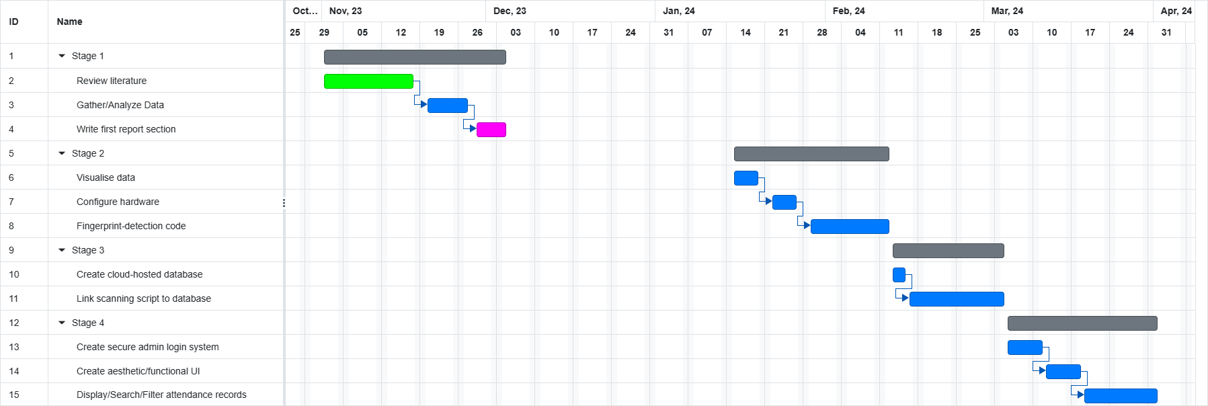

Figure 9: Research Methodology Gantt Chart

# Appendix B



Figure 5: Certificate of Ethical Approval

# References

Hutt, E. L. (2018). Measuring missed school: The historical precedents for the measurement and use of attendance records to evaluate schools. *Journal of Education for Students Placed at Risk (JESPAR)*, *23*(1-2), pp. 5-8.

Ramsbrock, D., Moskovchenko, S., & Conroy, C. (2006). Magnetic swipe card system security. *A case study of the University of Maryland, College Park*.

Clarke, N., & Furnell, S. (2005). Biometrics–The promise versus the practice. Computer Fraud & Security, 2005(9), pp. 12-16.

Ujan, I. A., & Ismaili, I. A. (2011, May). Biometric attendance system. In *The 2011 IEEE/ICME International Conference on Complex Medical Engineering*, pp. 499-501. IEEE.

Okereafor, K., Ekong, I., Markson, I. O., & Enwere, K. (2020). Fingerprint biometric system hygiene and the risk of COVID-19 transmission. *JMIR Biomedical Engineering*, *5*(1), e19623.

Masyn, S., Vuchelen, A., Santermans, E., Rasschaert, F., Bangura, A., Parys, W., & Rutten, R. (2019). Overcoming the challenges of iris scanning to identify minors (1–4 years) in the real-world setting. *BMC research notes*, *12*, pp. 1-6.

Drahansky, M., Dolezel, M., Urbanek, J., Brezinova, E., & Kim, T. H. (2012). Influence of skin diseases on fingerprint recognition. *BioMed Research International*, *2012*.

Mir, G. M., Balkhi, A. A., Lala, N. A., Sofi, N. A., Kirmani, M. M., & Mir, I. A. (2018). The benefits of implementation of biometric attendance system. *Oriental Journal of Computer Science and Technology*, *11*(1), pp. 50-54.

Jain, T., Tomar, U., Arora, U., & Jain, S. (2020). IoT based biometric attendance system. *International Journal of Electrical Engineering & Technology*, *11*(2), pp. 156-161.

Bais, M., Rawat, D., & Kaur, G. (2016). Biometric attendance system circuit. *Int. Journal of Engineering Applied Sciences and Technology*, *1*(6), pp. 195-199.

Chennattu, S., Kelkar, A., Anthony, A., & Nagdeote, S. (2019, November). Portable biometric attendance system using IoT. In *2019 4th International Conference on Information Systems and Computer Networks (ISCON)*, pp. 245-249. IEEE.

Andrejevic, M., & Selwyn, N. (2020). Facial recognition technology in schools: Critical questions and concerns. *Learning, Media and Technology*, *45*(2), pp. 115-128.

Kaur, N., & Juneja, M. (2014). A review on iris recognition. *2014 Recent Advances in Engineering and Computational Sciences (RAECS)*, pp. 1-5.

Karegar, F., Pettersson, J. S., & Fischer-Hübner, S. (2018, August). Fingerprint recognition on mobile devices: Widely deployed, rarely understood. In *Proceedings of the 13th International Conference on Availability, Reliability and Security*, pp. 1-9.

Marasco, E., & Ross, A. (2014). A survey on antispoofing schemes for fingerprint recognition systems. *ACM Computing Surveys (CSUR)*, *47*(2), pp. 1-36.

Patil, P., Khachane, A., & Purohit, V. (2016). A wireless fingerprint attendance system. *International Journal of Security, Privacy and Trust Management*, *5*(4), pp. 11-17.

Mohamed, B. K., & Raghu, C. V. (2012, December). Fingerprint attendance system for classroom needs. In *2012 Annual IEEE India Conference (INDICON)*, pp. 433-438. IEEE.

Tinmaz, H., Lee, Y. T., Fanea-Ivanovici, M., & Baber, H. (2022). A systematic review on digital literacy. *Smart Learning Environments*, *9*(1), pp. 1-18.

Van der Ploeg, I. (2005). Biometric identification technologies: ethical implications of the informatization of the body. *BITE Policy Paper*, *1*.

Tanwar, S., Tyagi, S., Kumar, N., & Obaidat, M. S. (2019). Ethical, legal, and social implications of biometric technologies. *Biometric-based physical and cybersecurity systems*, pp. 535-569.

Li, H., Yu, L., & He, W. (2019). The impact of GDPR on global technology development. *Journal of Global Information Technology Management*, *22*(1), pp. 1-6.

Koidan, K. (2021, December 21). *6 Reasons Why Python Is Used For Data Science*. LearnPython.com. <https://learnpython.com/blog/why-python-used-for-science/>

Harris, J. (2023, September 20). *Top Advantages and Disadvantages of R programming.* <https://www.theknowledgeacademy.com/blog/advantages-and-disadvantages-of-r-programming/>

Pounder, L. (2020, July 10). Raspberry Pi vs Arduino: Which Board is Best? *Tom’s Hardware*. <https://www.tomshardware.com/features/raspberry-pi-vs-arduino>

Anderson, B., Nicholson, B. (2022, June 12). *SQL vs. NoSQL Databases: What’s the Difference? - IBM Blog.* IBM Blog. https://www.ibm.com/blog/sql-vs-nosql/

Shankar, R. (2023, August 11). C# vs Python: Head to Head Comparison [Updated]. *Hackr.io*. <https://hackr.io/blog/c-sharp-vs-python>

End of 6000CEM Project Proposal

## Appendix B

### Links

Coventry University GitHub Repository: <https://github.coventry.ac.uk/adalata/6001CEM-Project-AA-11068789.git>

6001CEM Demonstration Video: <https://youtu.be/aA_EF-mDpeU>

### User Feedback

This section will show all responses to feedback questions left by participants. Note that the PIS has been omitted as has the consent form and all participant details. The consent form was signed by all users and contains no responses unique to each user. Both PIS and consent form can be viewed in the project proposal in Appendix A. Participants were anonymised during the course of this study but relevant names and contact information may be viewed in this section.

**Person 1:**

Figure 29: Participant information sheet of person 1, page 1



Figure 30: Participant information sheet of person 1, page 2



Figure 31: Consent form of person 1, page 1



Figure 32: Consent form of person 1, page 2



Figure 33: Feedback form of person 1, page 1



Figure 34: Feedback form of person 1, page 2



Figure 35: Feedback form of person 1, page 3

**Person 2:**

Figure 36: Participant information sheet of person 2, page 1



Figure 37: Participant information sheet of person 2, page 2



Figure 38: Consent form of person 2, page 1



Figure 39: Consent form of person 2, page 2



Figure 40: Feedback form of person 2, page 1



Figure 41: Feedback form of person 2, page 2



Figure 42: Feedback form of person 2, page 3

 **Person 3:**

Figure 43: Participant information sheet of person 3, page 1



Figure 44: Participant information sheet of person 3, page 2



Figure 45: Consent form of person 3, page 1



Figure 46: Consent form of person 3, page 2



Figure 47: Feedback form of person 3, page 1



Figure 48: Feedback form of person 3, page 2



Figure 49: Feedback form of person 3, page 3

 **Person 4:**

Figure 50: Participant information sheet of person 4, page 1



Figure 51: Participant information sheet of person 4, page 2



Figure 52: Consent form of person 4, page 1



Figure 53: Consent form of person 4, page 2



Figure 54: Feedback form of person 4, page 1



Figure 55: Feedback form of person 4, page 2



Figure 56: Feedback form of person 4, page 3

## Appendix C

**NOTE:** All scripts listed were created/modified by me. Any extra designer or markup scripts (As Visual Studio automatically generates and modifies these when operating the drag-and-drop interface designer) can be found in the GitHub repository, the link to which can be found in Appendix B.

### Form1.cs

//using System.Data.SQLite;

using MySql.Data;

using MySql.Data.MySqlClient;

using Mysqlx.Session;

using System.Data;

using System.Data.SQLite;

using System.Diagnostics.Eventing.Reader;

using System.Windows.Forms;

using System.Windows.Forms.DataVisualization.Charting;

using System.Xml.Linq;

using static System.Windows.Forms.VisualStyles.VisualStyleElement.ListView;

namespace BioPortal_AMS

{

public partial class Form1 : Form

{

MySql.Data.MySqlClient.MySqlConnection myConnection;

// Define server, user, password and database name

string ConnectionString = "server=127.0.0.1;uid=user;pwd=password;database=database_name";

public Form1()

{

InitializeComponent();

}

LoginPage loginPage;

private void Form1_Load(object sender, EventArgs e)

{

// Define backend procedures to run on first loading the page

comboBox1.SelectedIndex = 0; // Set dropdown filter default value to 'All'

refresh_table(); // Get initial student data

}

public void log_user(string email)

{

label1.Text = email;

}

// -------------------------REGISTER SECTION----------------------------

private void update_attendance(string studentId, bool presentStatus)

{

/**

Use student ID to switch bool value absent -> present, vice versa

Parameters: studentId - Student whose status requires updating

presentStatus - Whether student needs to be marked absent or present

Returns: N/A

*/

DateTime now = DateTime.Now; // Get current time to determine class of interest

using (var connection = new MySql.Data.MySqlClient.MySqlConnection(ConnectionString)) // Make temp connection

{

connection.Open(); // Open connection

using (MySqlCommand command = new MySqlCommand()) // Create command

{

command.Connection = connection; // Using the open connection

if (now.Hour > 12)

{

// If afternoon, mark student for PM class

command.CommandText = "UPDATE StudentsPM SET Present = @Present WHERE ID = @ID";

}

else

{

// If morning, mark student for AM class

command.CommandText = "UPDATE StudentsAM SET Present = @Present WHERE ID = @ID";

}

// Parametise command to prevent SQLi

command.Parameters.AddWithValue("@Present", presentStatus ? 1 : 0);

command.Parameters.AddWithValue("@ID", studentId);

command.ExecuteNonQuery(); // Execute command

}

}

}

private void refresh_table()

{

/**

Fetch data from MySQL db, fill dataGridView1

Parameters: N/A

Returns: N/A

*/

string name = textBox1.Text; // Get input from textbox

bool? present = null; // Intialise present bool

if (comboBox1.SelectedIndex == 1)

{

// If second option in dropdown selected, only show present

present = true;

}

else if (comboBox1.SelectedIndex == 2)

{

// If third option in dropdown selected, only show absent

present = false;

}

DataTable dtStudents = new DataTable(); // Define datatable

DateTime now = DateTime.Now; // Get current time

using (var connection = new MySql.Data.MySqlClient.MySqlConnection(ConnectionString)) // Make temp connection

{

connection.Open(); // Open connection

using (MySqlCommand command = new MySqlCommand()) // Create command

{

command.Connection = connection; // Using the open connection

if (now.Hour > 12)

{

// If afternoon, show student from PM class

command.CommandText = "SELECT id, name, gender, contact, present FROM StudentsPM WHERE Name LIKE @name";

}

else

{

// If morning, show student from AM class

command.CommandText = "SELECT id, name, gender, contact, present FROM StudentsAM WHERE Name LIKE @name";

}

// Parametise command to prevent SQLi

command.Parameters.AddWithValue("@name", $"%{name}%");

if (present.HasValue)

{

command.CommandText += " AND Present = @present";

command.Parameters.AddWithValue("@present", present.Value ? 1 : 0);

}

using (var adapter = new MySqlDataAdapter(command))

{

adapter.Fill(dtStudents); // Populate datatable with command results

}

}

}

dataGridView1.DataSource = dtStudents; // Show on dataGridView object

}

private void button2_Click(object sender, EventArgs e)

{

refresh_table(); // Refresh table when refresh button clicked

}

private void comboBox1_SelectedIndexChanged(object sender, EventArgs e)

{

refresh_table(); // Refresh table when dropdown value changed

}

private void textBox1_TextChanged(object sender, EventArgs e)

{

refresh_table();

}

private void button3_Click(object sender, EventArgs e)

{

if (dataGridView1.SelectedRows.Count > 0) // A row must be selected

{

// Get ID of selected, use to update present to True then reload table

string studentId = dataGridView1.SelectedRows[0].Cells["ID"].Value.ToString();

update_attendance(studentId, true);

refresh_table();

}

else

{

// Error message when no student selected

MessageBox.Show("Please select a student.");

}

}

private void button4_Click(object sender, EventArgs e)

{

if (dataGridView1.SelectedRows.Count > 0) // A row must be selected

{

// Get ID of selected, use to update present to True then reload table

string studentId = dataGridView1.SelectedRows[0].Cells["id"].Value.ToString();

update_attendance(studentId, false);

refresh_table();

}

else

{

// Error message when no student selected

MessageBox.Show("Please select a student.");

}

}

// ---------------------------MENU BUTTONS----------------------------

private void button5_Click(object sender, EventArgs e)

{

// When logout button is clicked, hide current page, only show login page

this.Hide();

loginPage = new LoginPage(this);

loginPage.ShowDialog();

}

private void button1_Click(object sender, EventArgs e)

{

Application.Exit(); // Close application

}

private void button6_Click(object sender, EventArgs e)

{

if (panel6.Visible == true && panel7.Visible == true)

{

panel6.Visible = false;

panel7.Visible = false;

}

else if (panel11.Visible == true)

{

panel11.Visible = false;

}

panel5.Show();

dataGridView1.Show();

label2.Text = "Register";

}

private void button7_Click(object sender, EventArgs e)

{

if (panel5.Visible == true && dataGridView1.Visible == true)

{

panel5.Visible = false;

dataGridView1.Visible = false;

}

else if (panel11.Visible == true)

{

panel11.Visible = false;

}

label2.Text = "Analytics";

panel6.Visible = true;

panel7.Visible = true;

refresh_chart();

}

private void button8_Click(object sender, EventArgs e)

{

if (panel6.Visible == true && panel7.Visible == true)

{

panel6.Visible = false;

panel7.Visible = false;

}

else if (panel5.Visible == true && dataGridView1.Visible == true)

{

panel5.Visible = false;

dataGridView1.Visible = false;

}

panel11.Visible = true;

label2.Text = "Settings";

}

// ---------------------------ANALYTICS SECTION----------------------------

private void refresh_chart()

{

/**

Populate bar chart with weekly absences from MySQL db table

Parameters: N/A

Returns: N/A

*/

using (var connection = new MySql.Data.MySqlClient.MySqlConnection(ConnectionString)) // Make temp connection

{

connection.Open(); // Open connection

using (MySqlCommand command = new MySqlCommand()) // Create command

{

command.Connection = connection; // Using the open connection

// Retrieve only required information in custom order

command.CommandText = "SELECT weekday, session, absent FROM attendanceForWeek\r\nORDER BY FIELD(weekday, 'Monday', 'Tuesday', 'Wednesday', 'Thursday', 'Friday')";

var reader = command.ExecuteReader(); // Execute query

while (reader.Read()) // For each weekday

{

// Convert required fields to from obj to str and to int for measured metric

string weekday = reader["weekday"].ToString();

string session = reader["session"].ToString();

int numberPresent = Convert.ToInt32(reader["absent"]);

double weekdayNumeric;

// Selection to map weekdays to integers

if (weekday == "Monday")

{

weekdayNumeric = 1;

}

else if (weekday == "Tuesday")

{

weekdayNumeric = 2;

}

else if (weekday == "Wednesday")

{

weekdayNumeric = 3;

}

else if (weekday == "Thursday")

{

weekdayNumeric = 4;

}

else

{

weekdayNumeric = 5;

}

// Unique value for every day-session combination

weekdayNumeric += (session == "AM" ? 0.1 : 0.3); // Split AM and PM using decimal

// Add data point, will add two columns due to differing decimal values

chart1.Series["PM Session (RIGHT)"].Points.AddXY(weekdayNumeric, numberPresent);

}

// Map integers back to weekdays for x axis labelling

chart1.ChartAreas[0].AxisX.CustomLabels.Add(1 + 0.1, 1 + 0.3, "Monday");

chart1.ChartAreas[0].AxisX.CustomLabels.Add(2 + 0.1, 2 + 0.3, "Tuesday");

chart1.ChartAreas[0].AxisX.CustomLabels.Add(3 + 0.1, 3 + 0.3, "Wednesday");

chart1.ChartAreas[0].AxisX.CustomLabels.Add(4 + 0.1, 4 + 0.3, "Thursday");

chart1.ChartAreas[0].AxisX.CustomLabels.Add(5 + 0.1, 5 + 0.3, "Friday");

}

}

}

// ---------------------------SETTINGS SECTION----------------------------

private void button9_Click(object sender, EventArgs e)

{

string password = textBox3.Text;

string confPassword = textBox4.Text;

LoginPage loginpage = new LoginPage(this);

if (loginpage.login_valid(label1.Text, textBox2.Text))

{

if (password.Any(Char.IsLetter) && password.Any(Char.IsDigit) && password.Length > 8)

{

if (password == confPassword)

{

RegisterPage registerPage = new RegisterPage();

string gensalt = registerPage.randSalt();

string hashedpass = registerPage.hash(password + gensalt);

string dbpass = hashedpass + '$' + gensalt;

using (var connection = new MySqlConnection(ConnectionString)) // Make temp connection

{

connection.Open(); // Open connection

using (var command = new MySqlCommand()) // Create command

{

command.Connection = connection; // Using open connection

command.CommandText = "UPDATE Logins SET password = @password WHERE email = @email";

// Parametise command to prevent SQLi

command.Parameters.AddWithValue("@password", dbpass);

command.Parameters.AddWithValue("@email", label1.Text);

command.ExecuteNonQuery(); // Execute command

}

}

registerPage.Close();

MessageBox.Show("Password successfully changed. Please restart application.");

}

else

{

MessageBox.Show("Passwords must match.");

}

}

else

{

MessageBox.Show("Passwords must be greater than 8 characters in length and contain a mix of alphanumeric characters.");

}

}

else

{

MessageBox.Show("Credentials invalid.");

}

loginpage.Close();

}

private void checkBox1_CheckedChanged(object sender, EventArgs e)

{

if (checkBox1.Checked)

{

button6.ForeColor = Color.FromArgb(32, 31, 31);

button6.BackColor = Color.FromArgb(232, 231, 231);

button7.ForeColor = Color.FromArgb(32, 31, 31);

button7.BackColor = Color.FromArgb(232, 231, 231);

button8.ForeColor = Color.FromArgb(32, 31, 31);

button8.BackColor = Color.FromArgb(232, 231, 231);

panel1.BackColor = Color.FromArgb(232, 231, 231);

panel2.BackColor = Color.FromArgb(242, 241, 241);

label1.BackColor = Color.FromArgb(242, 241, 241);

label1.ForeColor = Color.Black;

button5.BackColor = Color.FromArgb(242, 241, 241);

button5.BackgroundImage = Properties.Resources.LogOutLight;

panel3.BackColor = Color.FromArgb(232, 231, 231);

pictureBox2.BackColor = Color.FromArgb(232, 231, 231);

pictureBox2.Image = Properties.Resources.logo_bioportallightm;

this.BackColor = Color.FromArgb(225, 225, 225);

label2.BackColor = Color.FromArgb(225, 225, 225);

label2.ForeColor = Color.FromArgb(25, 25, 25);

button1.BackColor = Color.FromArgb(225, 225, 225);

button1.ForeColor = Color.FromArgb(25, 25, 25);

panel11.BackColor = Color.FromArgb(242, 241, 241);

label15.BackColor = Color.FromArgb(242, 241, 241);

label15.ForeColor = Color.FromArgb(42, 41, 41);

textBox2.BackColor = Color.FromArgb(255, 255, 255);

textBox3.BackColor = Color.FromArgb(255, 255, 255);

textBox4.BackColor = Color.FromArgb(255, 255, 255);

textBox2.ForeColor = Color.FromArgb(55, 55, 55);

textBox3.ForeColor = Color.FromArgb(55, 55, 55);

textBox4.ForeColor = Color.FromArgb(55, 55, 55);

label17.ForeColor = Color.FromArgb(42, 41, 41);

label18.ForeColor = Color.FromArgb(42, 41, 41);

label19.ForeColor = Color.FromArgb(42, 41, 41);

label17.BackColor = Color.FromArgb(242, 241, 241);

label18.BackColor = Color.FromArgb(242, 241, 241);

label19.BackColor = Color.FromArgb(242, 241, 241);

button9.BackColor = Color.Black;

button9.ForeColor = Color.White;

label16.BackColor = Color.FromArgb(242, 241, 241);

label16.ForeColor = Color.FromArgb(42, 41, 41);

checkBox1.ForeColor = Color.FromArgb(42, 41, 41);

checkBox1.BackColor = Color.FromArgb(242, 241, 241);

panel4.BackColor = Color.FromArgb(242, 241, 241);

panel5.BackColor = Color.FromArgb(242, 241, 241);

panel6.BackColor = Color.FromArgb(242, 241, 241);

panel7.BackColor = Color.FromArgb(242, 241, 241);

panel8.BackColor = Color.FromArgb(42, 41, 41);

panel9.BackColor = Color.FromArgb(42, 41, 41);

panel10.BackColor = Color.FromArgb(42, 41, 41);

dataGridView1.BackgroundColor = Color.FromArgb(242, 241, 241);

dataGridView1.ForeColor = Color.FromArgb(242, 241, 241);

button2.ForeColor = Color.FromArgb(42, 41, 41);

button2.BackColor = Color.FromArgb(242, 241, 241);

button3.ForeColor = Color.FromArgb(42, 41, 41);

button3.BackColor = Color.FromArgb(242, 241, 241);

button4.ForeColor = Color.FromArgb(42, 41, 41);

button4.BackColor = Color.FromArgb(242, 241, 241);

textBox1.BackColor = Color.FromArgb(242, 241, 241);

textBox1.ForeColor = Color.FromArgb(42, 41, 41);

comboBox1.BackColor = Color.FromArgb(242, 241, 241);

comboBox1.ForeColor = Color.FromArgb(42, 41, 41);

label14.BackColor = Color.FromArgb(242, 241, 241);

label14.ForeColor = Color.FromArgb(42, 41, 41);

label13.BackColor = Color.FromArgb(242, 241, 241);

label13.ForeColor = Color.FromArgb(42, 41, 41);

label12.BackColor = Color.FromArgb(242, 241, 241);

label12.ForeColor = Color.FromArgb(42, 41, 41);

label11.BackColor = Color.FromArgb(242, 241, 241);

label11.ForeColor = Color.FromArgb(42, 41, 41);

label10.BackColor = Color.FromArgb(242, 241, 241);

label10.ForeColor = Color.FromArgb(42, 41, 41);

label9.BackColor = Color.FromArgb(242, 241, 241);

label9.ForeColor = Color.FromArgb(42, 41, 41);

label8.BackColor = Color.FromArgb(242, 241, 241);

label8.ForeColor = Color.FromArgb(42, 41, 41);

label7.BackColor = Color.FromArgb(242, 241, 241);

label7.ForeColor = Color.FromArgb(42, 41, 41);

label6.BackColor = Color.FromArgb(242, 241, 241);

label6.ForeColor = Color.FromArgb(42, 41, 41);

label5.BackColor = Color.FromArgb(242, 241, 241);

label5.ForeColor = Color.FromArgb(42, 41, 41);

label4.BackColor = Color.FromArgb(242, 241, 241);

label4.ForeColor = Color.FromArgb(42, 41, 41);

label3.BackColor = Color.FromArgb(242, 241, 241);

label3.ForeColor = Color.FromArgb(42, 41, 41);

}

else

{

button6.ForeColor = Color.FromArgb(232, 231, 231);

button6.BackColor = Color.FromArgb(32, 31, 31);

button7.ForeColor = Color.FromArgb(232, 231, 231);

button7.BackColor = Color.FromArgb(32, 31, 31);

button8.ForeColor = Color.FromArgb(232, 231, 231);

button8.BackColor = Color.FromArgb(32, 31, 31);

panel1.BackColor = Color.FromArgb(32, 31, 31);

panel2.BackColor = Color.FromArgb(42, 41, 41);

label1.BackColor = Color.FromArgb(42, 41, 41);

label1.ForeColor = Color.White;

button5.BackColor = Color.FromArgb(42, 41, 41);

button5.BackgroundImage = Properties.Resources.LogOut;

panel3.BackColor = Color.FromArgb(32, 31, 31);

pictureBox2.BackColor = Color.FromArgb(32, 31, 31);

pictureBox2.Image = Properties.Resources.logo_bioportaldarkm;

this.BackColor = Color.FromArgb(25, 25, 25);

label2.BackColor = Color.FromArgb(25, 25, 25);

label2.ForeColor = Color.FromArgb(225, 225, 225); ;

button1.BackColor = Color.FromArgb(25, 25, 25);

button1.ForeColor = Color.FromArgb(225, 225, 225);

panel11.BackColor = Color.FromArgb(42, 41, 41);

label15.BackColor = Color.FromArgb(42, 41, 41);

label15.ForeColor = Color.FromArgb(242, 241, 241);

textBox2.BackColor = Color.FromArgb(55, 55, 55);

textBox3.BackColor = Color.FromArgb(55, 55, 55);

textBox4.BackColor = Color.FromArgb(55, 55, 55);

textBox2.ForeColor = Color.FromArgb(255, 255, 255);

textBox3.ForeColor = Color.FromArgb(255, 255, 255);

textBox4.ForeColor = Color.FromArgb(255, 255, 255);

label17.ForeColor = Color.FromArgb(242, 241, 241);

label18.ForeColor = Color.FromArgb(242, 241, 241);

label19.ForeColor = Color.FromArgb(242, 241, 241);

label17.BackColor = Color.FromArgb(42, 41, 41);

label18.BackColor = Color.FromArgb(42, 41, 41);

label19.BackColor = Color.FromArgb(42, 41, 41);

button9.BackColor = Color.White;

button9.ForeColor = Color.Black;

label16.BackColor = Color.FromArgb(42, 41, 41);

label16.ForeColor = Color.FromArgb(242, 241, 241);

checkBox1.ForeColor = Color.FromArgb(242, 241, 241);

checkBox1.BackColor = Color.FromArgb(42, 41, 41);

panel4.BackColor = Color.FromArgb(42, 41, 41);

panel5.BackColor = Color.FromArgb(42, 41, 41);

panel6.BackColor = Color.FromArgb(42, 41, 41);

panel7.BackColor = Color.FromArgb(42, 41, 41);

panel8.BackColor = Color.FromArgb(242, 241, 241);

panel9.BackColor = Color.FromArgb(242, 241, 241);

panel10.BackColor = Color.FromArgb(242, 241, 241);

dataGridView1.BackgroundColor = Color.FromArgb(42, 41, 41);

dataGridView1.ForeColor = Color.FromArgb(242, 241, 241);

button2.ForeColor = Color.FromArgb(242, 241, 241);

button2.BackColor = Color.FromArgb(42, 41, 41);

button3.ForeColor = Color.FromArgb(242, 241, 241);

button3.BackColor = Color.FromArgb(42, 41, 41);

button4.ForeColor = Color.FromArgb(242, 241, 241);

button4.BackColor = Color.FromArgb(42, 41, 41);

textBox1.BackColor = Color.FromArgb(55, 55, 55);

textBox1.ForeColor = Color.FromArgb(255, 255, 255);

comboBox1.BackColor = Color.FromArgb(55, 55, 55);

comboBox1.ForeColor = Color.FromArgb(255, 255, 255);

label14.BackColor = Color.FromArgb(42, 41, 41);

label14.ForeColor = Color.FromArgb(242, 241, 241);

label13.BackColor = Color.FromArgb(42, 41, 41);

label13.ForeColor = Color.FromArgb(242, 241, 241);

label12.BackColor = Color.FromArgb(42, 41, 41);

label12.ForeColor = Color.FromArgb(242, 241, 241);

label11.BackColor = Color.FromArgb(42, 41, 41);

label11.ForeColor = Color.FromArgb(242, 241, 241);

label10.BackColor = Color.FromArgb(42, 41, 41);

label10.ForeColor = Color.FromArgb(242, 241, 241);

label9.BackColor = Color.FromArgb(42, 41, 41);

label9.ForeColor = Color.FromArgb(242, 241, 241);

label8.BackColor = Color.FromArgb(42, 41, 41);

label8.ForeColor = Color.FromArgb(242, 241, 241);

label7.BackColor = Color.FromArgb(42, 41, 41);

label7.ForeColor = Color.FromArgb(242, 241, 241);

label6.BackColor = Color.FromArgb(42, 41, 41);

label6.ForeColor = Color.FromArgb(242, 241, 241);

label5.BackColor = Color.FromArgb(42, 41, 41);

label5.ForeColor = Color.FromArgb(242, 241, 241);

label4.BackColor = Color.FromArgb(42, 41, 41);

label4.ForeColor = Color.FromArgb(242, 241, 241);

label3.BackColor = Color.FromArgb(42, 41, 41);

label3.ForeColor = Color.FromArgb(242, 241, 241);

}

}

private void Form1_FormClosed(object sender, FormClosedEventArgs e)

{

Application.Exit(); // Prevent any background threads or forms running when app is closed

}

}

}

### LoginPage.cs

using System;

using System.Collections.Generic;

using System.ComponentModel;

using System.Data;

//using System.Data.SQLite; // Database handling

using MySql.Data; // Database handling

using MySql.Data.MySqlClient; // Database handling

using System.Drawing;

using System.Linq;

using System.Text;

using System.Threading.Tasks;

using System.Windows.Forms;

using System.Security.Cryptography; // Hashing

namespace BioPortal_AMS

{

public partial class LoginPage : Form

{

MySql.Data.MySqlClient.MySqlConnection myConnection;

// Define server, user, password and database name

string ConnectionString = "server=127.0.0.1;uid=user;pwd=password;database=database_name";

private Form1 mainPage;

public LoginPage(Form1 main)

{

InitializeComponent();

mainPage = main;

}

private void LoginPage_Load(object sender, EventArgs e)

{

}

private string hash(string s)

{

/**

Hashes inputted str using SHA-256

Parameters: s - String to be hashed

Returns: hashed - Hashed string

*/

var sha256 = SHA256.Create();

byte[] bytearray = sha256.ComputeHash(Encoding.UTF8.GetBytes(s));

string hashed = "";

for (int i = 0; i < bytearray.Length; i++)

{

hashed += (bytearray[i].ToString("x2"));

}

return hashed.ToString();

}

public bool login_valid(string email, string pw)

{

/**

Checks inputted email, pw against stored email, pw, returns true if match

Parameters: email - Inputted email to be checked

pw - Inputted password to be checked

Returns: True - Successful match / False - Credentials invalid

*/

using (var connection = new MySqlConnection(ConnectionString)) // Make temp connection

{

connection.Open(); // Open connection

using (var command = new MySqlCommand()) // Create command

{

command.Connection = connection; // Using open connection

command.CommandText = "SELECT password FROM logins WHERE email = @email";

// Parametise command to prevent SQLi

command.Parameters.AddWithValue("@email", email);

using (MySqlDataReader reader = command.ExecuteReader())

{

if (reader.HasRows)

{

reader.Read();

var splitPass = reader.GetString(0).Split("$");

pw += splitPass[1];

if (hash(pw) == splitPass[0]) // If user login details are correct

{

return true;

}

return false;

}

return false;

}

}

}

}

private void button1_Click(object sender, EventArgs e)

{

if (textBox2.PasswordChar == '*') // If password is currently hidden

{

textBox2.PasswordChar = '\0'; // Show password

}

else // Else if password is showing

{

textBox2.PasswordChar = '*'; // Hide password

}

}

private void button2_Click(object sender, EventArgs e)

{

// Take inputs of textBox1 and textBox2 as username and password

if (login_valid(textBox1.Text, textBox2.Text))

{

// When login button is clicked, hide current page, only show main page

mainPage.log_user(textBox1.Text);

mainPage.ShowDialog();

this.Hide();

}

else

{

MessageBox.Show("Credentials invalid.");

}

}

private void label1_Click(object sender, EventArgs e)

{

Application.Exit(); // Close application

}

private void label3_Click(object sender, EventArgs e)

{

// Open register page

this.Hide();

RegisterPage register = new RegisterPage();

register.Show();

}

private void LoginPage_FormClosed(object sender, FormClosedEventArgs e)

{

Application.Exit(); // Prevent any background threads or forms running when app is closed

}

}

}

### RegisterPage.cs

using System;

using System.Collections.Generic;

using System.ComponentModel;

using System.Data;

using MySql.Data; // Database handling

using MySql.Data.MySqlClient; // Database handling

// using System.Data.SQLite;

using System.Drawing;

using System.Linq;

using System.Text;

using System.Text.RegularExpressions;

using System.Threading.Tasks;

using System.Windows.Forms;

using System.Security.Cryptography; // Hashing

using System.Xaml.Permissions;

namespace BioPortal_AMS

{

public partial class RegisterPage : Form

{

// Use relative over absolute path

//string dbPath = Path.GetFullPath(Path.Combine(AppDomain.CurrentDomain.BaseDirectory, @"..\..\..", "students.db")); // Navigate to working directory

//private string ConnectionString; // Initialise ConnectionString

MySql.Data.MySqlClient.MySqlConnection myConnection;

//set the correct values for your server, user, password and database name

string ConnectionString = "server=127.0.0.1;uid=user;pwd=password;database=database_name";

public RegisterPage()

{

InitializeComponent();

}

private void RegisterPage_Load(object sender, EventArgs e)

{

}

public string hash(string s)

{

/**

Hashes inputted str using SHA-256

Parameters: s - String to be hashed

Returns: hashed - Hashed string

*/

var sha256 = SHA256.Create(); // New instance of Sha256

// Compute hash on s after converting to bytearray using utf-8

byte[] bytearray = sha256.ComputeHash(Encoding.UTF8.GetBytes(s));

string hashed = ""; // Initialise empty hash str

for (int i = 0; i < bytearray.Length; i++) // For each value in bytearray

{

hashed += (bytearray[i].ToString("x2")); // Convert to str (2-char hex)

}

return hashed.ToString();

}

public string randSalt()

{

/**

Generates salt value using random alphanumeric combination

Parameters: Letters - Characters to be picked from at random

Returns: newSalt - Random salt value

*/

string Letters = "6kXpx7VTYg5HrhO4JMsBmSiDoau0GldzCtNe1Efn8RbjyQqFwPZcIU3KLvW9A2";

var newSalt = "";

Random rand = new Random(); // New random object

for (int i = 0; i < rand.Next(5, 11); i++) // Min length 5, max length 11

{

int letterIndex = rand.Next(Letters.Length);

newSalt += Letters[letterIndex];

}

return newSalt;

}

private bool details_valid(string inst_code, string password)

{

/**

Checks if password meets security requirements and if institution exists, return true if conditions met

Parameters: inst_code - Inputted institution code to be checked

password - Inputted password to be checked

Returns: True - Validation successful / False - Password or institution invalid

*/

if (password.Any(Char.IsLetter) && password.Any(Char.IsDigit))

{

if (password.Length > 8)

{

using (var connection = new MySqlConnection(ConnectionString)) // Make temp connection

{

connection.Open(); // Open connection

using (var command = new MySqlCommand()) // Create command

{

command.Connection = connection; // Using open connection

command.CommandText = "SELECT * FROM academicinstitutions WHERE institutionCode = @code";

// Parametise command to prevent SQLi

command.Parameters.AddWithValue("@code", inst_code);

using (MySqlDataReader reader = command.ExecuteReader())

{

if (reader.HasRows)

{

return true;

}

else

{

MessageBox.Show("Please enter a valid institution.");

return false;

}

}

}

}

}

else

{

MessageBox.Show("Passwords must be greater than 8 characters in length.");

return false;

}

}

else

{

MessageBox.Show("Passwords must contain a mix of alphanumeric characters.");

return false;

}

}

private void ins_entry(string inst_code, string email, string fullname, string password)

{

/**

Creates new login record within MySQL db

Parameters: inst_code - Institution code to insert

email - Email to insert

fullname - Name to insert

password - password to salt, hash and insert

Returns: N/A

*/

string[] splitname = fullname.Split(" ");

string firstname = splitname[0];

string surname = splitname[splitname.Length-1];

string gensalt = randSalt();

string hashedpass = hash(password + gensalt);

string dbpass = hashedpass + '$' + gensalt;

using (var connection = new MySqlConnection(ConnectionString)) // Make temp connection

{

connection.Open(); // Open connection

using (var command = new MySqlCommand()) // Create command

{

command.Connection = connection; // Using open connection

command.CommandText = "INSERT INTO Logins (institutionCode, email, password, firstname, surname) VALUES (@code, @email, @pass, @firstname, @surname)";

// Parametise command to prevent SQLi

command.Parameters.AddWithValue("@code", inst_code);

command.Parameters.AddWithValue("@email", email);

command.Parameters.AddWithValue("@pass", dbpass);

command.Parameters.AddWithValue("@firstname", firstname);

command.Parameters.AddWithValue("@surname", surname);

command.ExecuteNonQuery(); // Execute command

}

}

}

private void button1_Click(object sender, EventArgs e)

{

if (textBox5.PasswordChar == '*') // If password is currently hidden

{

textBox5.PasswordChar = '\0'; // Show password

}

else // Else if password is showing

{

textBox5.PasswordChar = '*'; // Hide password

}

}

Form1 form1 = new Form1();

private void button2_Click(object sender, EventArgs e)

{

// Take inputs of textBox1 and textBox2 as username and password

if (details_valid(textBox1.Text, textBox5.Text))

{

ins_entry(textBox1.Text, textBox3.Text, textBox4.Text, textBox5.Text);

// If registration successful, hide current page, only show login page

this.Hide();

LoginPage Login = new LoginPage(form1);

Login.Show();

}

}

private void label1_Click(object sender, EventArgs e)

{

// Back to login

this.Hide();

LoginPage Login = new LoginPage(form1);

Login.Show();

}

private void label3_Click(object sender, EventArgs e)

{

}

private void textBox1_TextChanged(object sender, EventArgs e)

{

using (var connection = new MySql.Data.MySqlClient.MySqlConnection(ConnectionString)) // Make temp connection

{

connection.Open(); // Open connection

using (MySqlCommand command = new MySqlCommand()) // Create command

{

command.Connection = connection; // Using the open connection

command.CommandText = "SELECT institution FROM academicinstitutions WHERE institutioncode = @code";

// Parametise command to prevent SQLi

command.Parameters.AddWithValue("@code", textBox1.Text);

using (MySqlDataReader reader = command.ExecuteReader())

{

if (reader.HasRows)

{

reader.Read();

textBox2.Text = reader.GetString(0);

}

else if (textBox1.Text == "")

{

textBox2.Text = "";

}

else

{

textBox2.Text = "Not Found";

}

}

}

}

}

}

}

### Program.cs

namespace BioPortal_AMS

{

internal static class Program

{

/// <summary>

/// The main entry point for the application.

/// </summary>

[STAThread]

static void Main()

{

// To customize application configuration such as set high DPI settings or default font,

// see https://aka.ms/applicationconfiguration.

ApplicationConfiguration.Initialize();

Form1 form1 = new Form1();

Application.Run(new LoginPage(form1)); // Login screen is first to appear at runtime

}

}

}